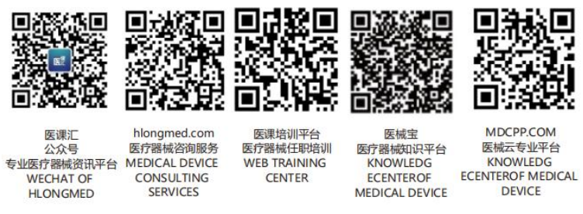GHTF/SG2/N87:2012



FINAL DOCUMENT
Global Harmonization Task Force

Title: An XML Schema for the electronic transfer of adverse event data between manufacturers, authorised representatives and National Competent Authorities (Based on GHTF/SG2/N54: 2006)

Authoring Group: Study Group 2 of the Global Harmonization Task Force

Endorsed by: The Global Harmonization Task Force

Date: July 27th, 2012

Dr. Kazunari Asanuma, GHTF Chair

This document was produced by the Global Harmonization Task Force, a voluntary international group of representatives from medical device regulatory authorities and trade associations from Europe, the United States of America (USA), Canada, Japan and Australia.

The document is intended to provide non-binding guidance to regulatory authorities for use in the regulation of medical devices, and has been subject to consultation throughout its development.

There are no restrictions on the reproduction, distribution or use of this document; however, incorporation of this document, in part or in whole, into any other document, or its translation into languages other than English, does not convey or represent an endorsement of any kind by the Global Harmonization Task Force.

Copyright © 2012 by the Global Harmonization Task Force
Table of Contents

1. Scope 4
2. References 5
3. Definitions 5
4. Use of the medical device adverse event reporting XML schema 5
5. Spreadsheet showing field names and workflow of XML schema 5
6. Medical device adverse event reporting XML schema 6

Preface

The document herein was produced by the Global Harmonization Task Force, a voluntary group of representatives from medical device regulatory agencies and the regulated industry. The document is intended to provide non-binding guidance for use in the regulation of medical devices, and has been subject to consultation throughout its development.
There are no restrictions on the reproduction, distribution or use of this document; however, incorporation of this document, in part or in whole, into any other document, or its translation into languages other than English, does not convey or represent an endorsement of any kind by the Global Harmonization Task Force.
Introduction

Important safety information concerning medical devices needs to be communicated by the fastest, most efficient means. The basic information necessary for medical device related adverse event reporting has already been agreed between international regulators and manufacturers representative organisations represented within GHTF Study Group 2 and issued as a final document GHTF/SG2/N54:2006.

Manufacturer representatives and National Competent Authorities recognise that a harmonized electronic transfer of adverse event datasets from manufacturers systems to relevant National Competent Authorities can offer significant efficiency gains and help improve response times for all concerned parties. It is expected that electronic reporting will become the method of choice in the future. GHTF has therefore developed this guidance document to encourage harmonized global development of electronic medical device adverse event reporting, based on GHTF/SG2/N54:2006.

This document presents an XML schema that has been developed using GHTF SG2 N54:2006. It should allow manufacturers or their authorized representatives and Competent Authorities to gain experience in the use of the XML schema.

GHTF recommends that those NCAs considering introducing electronic adverse event reporting facilities for manufacturers should develop systems that use N87, rather than a completely different data structure. However, it is very likely that national competent authorities will have to accept reports in other formats (paper form, Word file, email, etc) for some time into the future.

We recognize that some other electronic data exchange systems exist, therefore mapping will be required to allow for exchange of data.

Scope
This guidance provides details of an electronic format for manufacturers and Competent Authorities to use when exchanging adverse incident data electronically. The guidance comprises:

- A rationale for a customised XML schema for manufacturer reporting based on GHTF/SG2/N54:2006 (this document).
- A spreadsheet giving the field names used in GHTF/SG2/N54:2006 and the field names and workflow embedded within the XML schema (<N87 spreadsheet for XML schema based on N54:2006.xls>)
- An XML schema for manufacturer reporting based on GHTF/SG2/N54:2006. This consists of four separate electronic files (<n87-initial.xsd; n87-followup.xsd; n87-initialfinal.xsd; n87-final.xsd) representing the portion of the schema relevant to initial, follow-up, final and combined initial and final.

The six electronic documents together comprise the GHTF/SG2/N87:2012 guidance document bundle.

Guidance on what and when to report to Competent Authorities is contained GHTF/SG2/N54:2006.

References
GHTF/SG2/N54:2006: Medical Device Postmarket Vigilance and Surveillance: Global Guidance for Adverse Event Reporting for Medical Devices

Definition
XML
Extensible Markup Language (XML): A condensed form of Standard Generalized Markup Language (SGML) that enables developers to create customized tags that offer flexibility in organizing and presenting information. XML enables data to be organized and exchanged in ways that were previously impossible or very difficult. By using customised XML schemas, specific pieces of business data can be identified and extracted from ordinary business documents.

Use of the medical device adverse event reporting XML schema

This XML schema has been developed to facilitate a harmonised method for exchanging electronically an adverse event dataset based upon GHTF/SG2/N54:2006.
National Competent Authorities and manufacturers are encouraged to use this internationally agreed XML schema for exchanging adverse event data.
The XML schema allows adverse event data to be completed in English and/or, where necessary, in the language required by the relevant National Competent Authorities.

Spreadsheet showing field names and workflow of XML schema

The spreadsheet as a part of this guidance document, shows:
- how the fields listed in GHTF/SG2/N54:2006 map into the XML schema presented in <n87-initial.xsd; n87-followup.xsd; n87-initialfinal.xsd; n87-final.xsd;>. Based on regional requirements the xml schema has some fields that are not listed in GHTF/SG2/N54:2006. In those cases, the GHTF/SG2/N54:2006 field name has been left blank.
- the field name changes that have been introduced into the XML schema field annotations to clarify field content descriptions
- where relevant, details of the picklist elements that will be available for each field
- the workflow built into the XML schema that determines what data field content conditions are required for initial, follow-up, final and trend reports.

Medical device adverse event reporting XML schema

The XML schema for adverse event reporting is provided in <n87-initial.xsd; n87-followup.xsd; n87-initialfinal.xsd; n87-final.xsd > which is part of the GHTF/SG2/N87:2012 guidance document.

