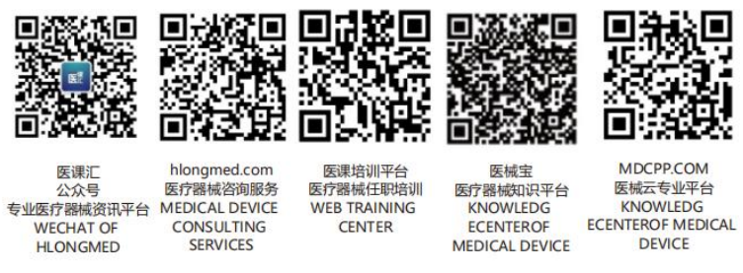GHTF/SC/N1R8:2005


FINAL DOCUMENT
Global Harmonization Task Force

Title: GHTF Guiding Principles

Authoring Group: GHTF Steering Committee

Endorsed by: The Global Harmonization Task Force

Date: May 20, 2005
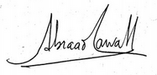
Abraao Carvalho, GHTF Chair

This document was produced by the Global Harmonization Task Force, a voluntary international group of representatives from medical device regulatory authorities and trade associations from Europe, the United States of America (USA), Canada, Japan and Australia.

There are no restrictions on the reproduction, distribution or use of this document; however, incorporation of this document, in part or in whole, into any other document, or its translation into languages other than English, does not convey or represent an endorsement of any kind by the Global Harmonization Task Force.

Copyright © 2000 by the Global Harmonization Task Force

Table of Contents

Preface
1.0 Introduction 4
2.0 Goals and Objectives 4
2.1. Goals 4
2.2. Objectives 4
3.0 Governing Principles 5
3.1 International Cooperation 5
3.2 Consensus 5
3.3 Implementation 5
3.4 Cooperation 5
3.5 Transparency 5
3.6 Continuous Review 6

Preface

This document was produced by the Global Harmonization Task Force, a voluntary international group of representatives from medical device regulatory authorities and trade associations from the European Union (EU) and EFTA (European Free Trade Association), the United States of America (USA), Canada, Japan and Australia.

The original version of this document was endorsed by GHTF in September 2000 and it was foreseen at that time that the text would undergo periodic revisions. A review of this document was undertaken in 2005. This text is the result of that review.

There are no restrictions on the reproduction, distribution, translation or use of this document however, incorporation of this document, in part or in whole, into any other document does not convey or represent an endorsement of any kind by the Global Harmonization Task Force.

Introduction
The guiding principles outlined in this document, in conjunction with the “GHTF Roles and Responsibilities” and “GHTF Operating Procedures” and the “GHTF Strategic Directions”, are designed to be flexible so that should the need arise, the GHTF can respond to challenges with respect to its objectives in a timely manner.

Goals and Objectives

2.1. Goals
The goal of the Global Harmonization Task Force is to provide a collaborative forum for representatives of member national regulatory authorities and industry representatives to promote international convergence in regulatory requirements and practices, in particular to:

- promote the safety, effectiveness/ performance and quality of medical devices,
- encourage technological innovation,
- foster international trade,
- serve as an information exchange forum through which countries with medical device regulatory systems under development can benefit from the experience of those with established systems and/or pattern their practices upon those of GHTF documents,
Notwithstanding the above, it is recognized that participating regulatory authorities retain the right to regulate according to their applicable sovereign regulations.

2.2. Objectives
To achieve the above goals the objectives of GHTF are:

(A) to encourage the development of a harmonized regulatory environment, allowing for better protection of public health, and thereby facilitating the availability of medical technologies consistent with the state of the art and current knowledge,

(B) the development of guidance documents and recommended procedures in order to work towards convergence of the medical device regulatory systems of its Members within the boundaries of their legal and institutional constraints,

(C) to define common elements of the regulatory systems of its Members and to work towards a coherent implementation of these elements, to encourage the development of related common data sets and their acceptance by regulatory authorities with the aim of avoiding duplication of files,

(D) to facilitate the development of an international post-market and vigilance system that will reduce the likelihood of repeated adverse events and influence the development of new medical devices,

(E) serve as platform for the exchange of information between Competent Authorities with established regulatory systems,

(F) to foster international cooperation between countries with established and developing regulatory systems.

Governing Principles

International Cooperation

The guiding spirit of GHTF is one of international cooperation between regulators and industry to achieve its goals and objectives.

Consensus

GHTF takes all decisions and actions by consensus.

Implementation
GHTF members will take appropriate steps to implement GHTF guidance and policies within the boundaries of their legal and institutional constraints.

Regulatory authorities agree to promote the GHTF documents within their own jurisdictions and, in the course of time, seek convergence of regulatory practices.

While regulators hold the ultimate responsibility for implementation, it is recognized that successful implementation requires the concerted best efforts of regulators and industry.

Cooperation
GHTF is committed to collaboration with non-founding members, international standard-setting bodies and/or public health organizations in order to share the experiences gained with its Member’s regulatory systems. The intent is to promote the implementation of GHTF guidance and to avoid duplication of work.

3.5 Transparency
GHTF is guided by the principle that its activities are transparent. This includes making documents in development available for comment at appropriate stages and keeping the GHTF website as current and accurate as possible.

3.6 Continuous Review
In order to keep all GHTF guidance up to date GHTF will regularly review its documents and guidance and revise them as required.

