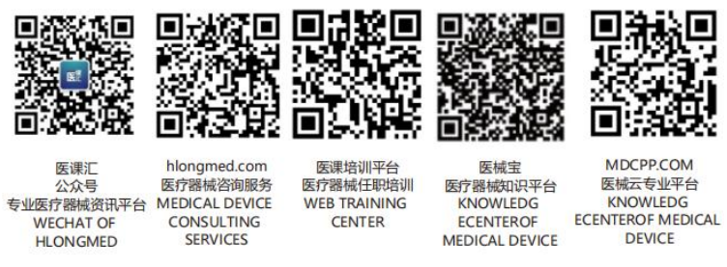GHTF/AHWG-GRM/N1R13:2011



Final Document

Title: The GHTF Regulatory Model

Authoring Group: Ad Hoc GHTF SC Regulatory Model Working Group

Endorsed by: The Global Harmonization Task Force

Date: 13 April 2011

[Signature], GHTF Chair
This document was produced by the Global Harmonization Task Force, a voluntary international group of representatives from medical device regulatory authorities and trade associations from Europe, the United States of America (USA), Canada, Japan and Australia.
The document is intended to provide non-binding guidance to regulatory authorities for use in the regulation of medical devices, and has been subject to consultation throughout its development.
There are no restrictions on the reproduction, distribution or use of this document; however, incorporation of this document, in part or in whole, into any other document, or its translation into languages other than English, does not convey or represent an endorsement of any kind by the Global Harmonization Task Force.
Copyright © 2011 by the Global Harmonization Task Force
Table of Contents
1 Introduction 4
2 Rationale, Purpose and Scope 4
2.1 Rationale 4
2.2 Purpose 5
2.3 Scope 5
3 Definitions 5
4 Evolution of the GHTF Regulatory Model 5
5 The Life Cycle of a Medical Device 6
6 Aspects of the GHTF Regulatory Model 9
6.1 Use of the GHTF Regulatory Model and Alternative Models 9
6.2 Current Regulatory Paradigms of the GHTF Founding Members 9
6.3 Roles and Responsibilities of National Competent Authorities (NCA), Conformity Assessment Bodies (CAB), and Manufacturers 10
7 Elements of the GHTF Model 12
7.1 The fundamental, harmonized elements of the GHTF Regulatory Model 12
7.2 Other important elements of the GHTF Regulatory Model 12
7.3 Additional regulatory elements not within the scope of the current work of the GHTF 12
8 Graphic Representations of the GHTF Regulatory Model 12
8.1 Flow Chart Format 13
8.2 Combined Representation of the GHTF Regulatory Model 16
9 GHTF Study Groups and Related Documents 17
9.1 Pre-market Evaluation 17
9.2 Post-market Surveillance/Vigilance 18
9.3 Quality Systems 19
9.4 Auditing 20
9.5 Clinical Safety/Performance 21
10 The GHTF Regulatory Model Dynamics and Interrelationships 22
11 Outline of Progressive Implementation of Elements of the GHTF Regulatory Model 23
11.1 Basic level framework: 24
11.2 Medium level framework: 25
11.3 Highest level framework: 25
12 References 26
12.1 SG1 26
12.2 SG2 26
12.3 SG3 26
12.4 SG4 27
12.5 SG5 27
12.6 ISO Standards 27

Introduction
The objective of the Global Harmonization Task Force (GHTF) is to encourage convergence at the global level in the evolution of regulatory systems for medical devices in order to facilitate trade while preserving the right of participating members to address the protection of public health by those regulatory means considered the most suitable.
The primary way in which the GHTF achieves its goals is through the production of a series of guidance documents that together provide a compilation of important elements that would constitute and describe a global regulatory model for medical devices. The purpose of such guidance is to provide a regulatory framework that would help eliminate differences between jurisdictions, decrease the cost of gaining regulatory compliance, allow patients, users, and others earlier access to new technologies and treatments and maintain a safe and effective level of healthcare over time through efficient post-market surveillance.
This document has been developed to encourage and support global convergence of regulatory systems based on the GHTF guidance documents. It is intended for use by all key stakeholders including regulatory authorities, Conformity Assessment Bodies (CAB) and industry. The intent is that through an internationally harmonized regulatory framework, there would be benefits in establishing, in a consistent way, an economic and effective approach to assure the consistent safety, quality, and performance/effectiveness of medical devices in the interest of public health.
GHTF supports and encourages international regulatory harmonization but recognizes that regulatory authorities may have to consider their local needs when they introduce new medical device regulations based on their existing legal framework. However, regulatory authorities that are developing regulations for medical devices, or amending existing ones, are encouraged to consider the adoption of the GHTF regulatory model, or modify their current system as outlined in the GHTF model, as this will help to reduce variations among systems world-wide and facilitate the process of international regulatory convergence.

Rationale, Purpose and Scope

Rationale
Medical devices regulatory systems are primarily intended to help protect and promote the public health and safety. Public trust and confidence in these systems depends upon the maintenance of safety and performance of medical devices throughout their life-cycle.
Legislators and regulatory authorities determine the extent and complexity of the regulatory controls governing all aspects of the medical device life-cycle. They also designate which part of the public service infrastructure is responsible for regulating different parts of the life-cycle. Each designated regulatory authority implements laws, regulations, guidance, or policies and procedures governing aspects of the medical device life-cycle for which it is responsible. A clear and coordinated system of regulatory controls throughout the medical device life-cycle, in conjunction with the manufacturer’s quality system, facilitates safety and performance of medical devices. Use of harmonized, coordinated controls expands the public health benefits, enables cross-border leveraging of regulatory resources, and reduces burdens to the regulated industry.
The GHTF has created over time guidance documents that together are providing an overall view of a internationally harmonized medical device regulatory model. The GHTF Steering Committee considered it would be very useful to have in one document an overall view on all developed GHFT guidances that, together, would provide a concise harmonized medical device regulatory model.
It is hoped that promotion and adoption of GHTF guidance will lead to international convergence of regulatory requirements and practices for medical devices.

Purpose
This guidance document is intended to integrate the existing GHTF guidance documents and show their interrelationships throughout the medical device life-cycle and to describe the GHTF Regulatory Model based upon:
- Guidance documents created by the GHTF Study Groups (SG)
- International standards
- Important and core elements of a regulatory model considered by the GHTF Steering Committee, Ad-Hoc working groups (AHWG) or Study Groups but not yet proposed as work items for development
- Documents which are under development by the GHTF are considered but are not referenced.

Scope
This document provides an overview of a Regulatory Model as developed by GHTF. It describes only the core and basic elements but it does not describe those elements in detail. The details are described in the referenced GHTF Study Groups’ guidance and other documents (see Section 12).
Be advised that the referenced documents may be updated from time to time and new documents will be added. The GHTF Regulatory Model document may then require amendment and regular updates. The public should use the most current GHTF documents as listed in www.ghtf.org.

Definitions
Life-cycle: all phases in the life of a medical device, from the initial conception to final decommissioning and disposal (ISO 14971:2007).
Marketing: the distribution and/or use of a device in commerce (based on definition of Supplying to the Market).
Product Realization: the process starting with planning and proceeding through determination of customer requirements and customer communication, design and development, purchasing, production, servicing, control of monitoring and measuring devices, and including delivery of the medical device (ISO 13485:2003).
Note: For further definitions please refer to GHTF SC(PD)N4 Glossary document.

Evolution of the GHTF Regulatory Model
The GHTF was created in 1992. Initially, the Study Groups independently initiated work plans and developed guidance until the GHTF Steering Committee was formed and GHTF procedures were established. The GHTF Study Group (SG) work plans in the 1990’s were not guided by a documented GHTF model. Rather, it was the consensus of the GHTF members in the 1990’s that work should begin on several common aspects of the regulatory practices of the five Founding Members. New international standards affecting medical devices regulatory practices, the revision of regulatory systems of some of the Founding Members, and emerging regulatory systems around the world also initially catalyzed work in quality management systems and other aspects of the medical device life-cycle.
GHTF guidance development has continued under five major regulatory groupings including: Pre-market Evaluation, Post-Market Surveillance/Vigilance, Quality Systems, Regulatory Auditing, and Clinical Safety/Performance. The GHTF members recognized these subject groups as areas of common interest and relevant to all their regulatory systems.
In order to help set the GHTF work program in an overall context; Study Group 1 posted for public view an overview of the overall GHTF program. Study Group 2 similarly produced integrated descriptions of their work program.
At the GHTF Steering Committee meeting in Kuala Lumpur, Malaysia in 2008 the committee determined that a GHTF Regulatory Model document should be produced. Such a document would, for example:
- Be a focal point for understanding how all the GHTF guidance documents interrelate,
- Identify areas of the model where GHTF has not developed guidance,
- Be a basis for training,
- Assist regulators in developing regulatory systems based on the GHTF harmonised model,
- Support and encourage the work of regional regulatory harmonization initiatives
- Illustrate the relationship of regulatory controls during the product life-cycle.

The Life Cycle of a Medical Device
Figure 1 illustrates the fundamental life-cycle of a medical device. It demonstrates that medical device development is a continuous process from the initial concept of the device → to the various phases of product realization → to placing the device on the market → to marketing of the product through distribution, promotion, advertising, servicing → to obsolescence or renewal as a modified product. The figure also illustrates the fact that there are relationships among the phases of the life-cycle. For example, experience gathered in the marketing phase feeds back into the design and testing of new products, product improvements, or corrective actions.

Figure 1. Medical Device Life-cycle

Figure 2 illustrates the application of regulatory processes to the product life-cycle. The entire cycle is subject to the regulatory processes of a Quality Management System (QMS), Risk Management, and Regulatory Auditing. Pre-market regulatory controls, such as Competent Authority or conformity assessment body review (valid in some jurisdictions) of summary technical files, may apply during product realization. The product is then supplied to the market subject to regulatory controls such as registration of the manufacturer. Post-market surveillance, vigilance controls and adverse event reporting apply during the marketing phase of the device.

Figure 2. Medical Device Life-Cycle with Regulatory Aspects Applied

Figure 3 displays the same information described in Figures 1 and 2, but in a linear representation. Here the regulatory model is displayed as three primary stages, including the Pre-market and Post-market stages. The regulatory activities within each stage are noted.

Figure 3. Product Life-Cycle, Linear Representation with Applied Processes¹
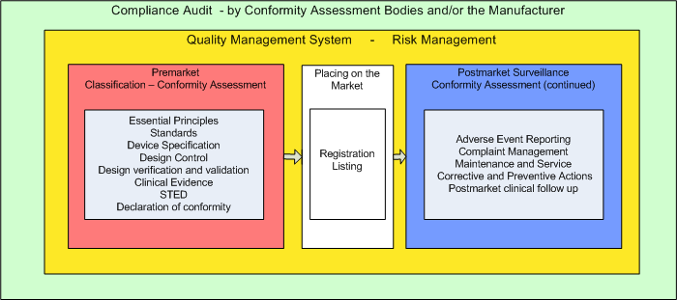¹ Note that the regulatory audit requirements depend on the device risk classification with no audit required for class A devices. (STED: Summary Technical Documentation for demonstrating conformity to the Essential Principles of Safety and Performance)

Aspects of the GHTF Regulatory Model

Use of the GHTF Regulatory Model and Alternative Models
The GHTF Regulatory Model incorporates harmonized regulatory processes to be considered and applied at the federal, national, regional or economy level, as appropriate. Medical device life-cycle models described in non-GHTF publications may or may not be consistent with the GHTF-based Model. The non-GHTF models may address factors unique to those jurisdictions, or factors not addressed in a GHTF document.

Current Regulatory Paradigms of the GHTF Founding Members
The GHTF Regulatory Model is comprised of interlinked subsystems, e.g., pre-market and post-market vigilance/surveillance, which together describe a coordinated, harmonized regulatory program that safeguards public health. All the GHTF Founding Members subscribe to the fundamental concept of the GHTF model and strive to incorporate the study group guidance documents, which describe detailed aspects of the model, into their regulations.
Two different regulatory paradigms exist within the Founding Member countries. One paradigm is where the Competent Authority is responsible for the national medical device regulatory activities and also undertakes a majority of them itself. The other utilizes Conformity Assessment Bodies to carry out some of the tasks on behalf, and under the supervision, of the Competent Authorities.
In both systems, the ultimate responsibility for ensuring that a medical device complies with the regulations that apply to it, resides with the manufacturer.

Roles and Responsibilities of National Competent Authorities (NCA), Conformity Assessment Bodies (CAB), and Manufacturers
The GHTF Regulatory Model, and the GHTF documents upon which it is based, incur responsibilities for the stakeholders in the regulatory system, i.e., the manufacturer, the regulator e.g. National Competent Authority, and the Conformity Assessment Body. Tables 1-3 illustrate some of these roles and responsibilities and how they related to the guidance areas covered by the GHTF study groups.

Table 1. National Competent Authority Roles and Responsibilities1
 | General  (Not covered in GHTF guidance) | SG-1  Pre-market | SG-2  Post-market | SG-3  QMS | SG-4  QMS Audit | SG-5  Clinical (not covered by GHTF guidance)
National Competent Authority (NCA) | - Link gov’t policies and priorities to regulatory system  - Consult stakeholders  - Draft and adopt laws and regulations  - Appoint and oversee CABs  - Maintain adequate resources  - Enforce laws and regulations  - Import/export controls | - Define ‘medical device’ (MD) (N029)  - Registration of mfrs., importers, and distributors and device listing (N65)  - Establish MD classification rules (N015)  - Establish ‘essential principles’ of safety and performance (N041)  - Recognise standards (N044)  - Pre-market conformity assessment (N040) | - Establish Adverse Event Report (AER) Requirements (N54)  - Establish and maintain national vigilance database  - Evaluate AER received  - Monitor mfr. Investigation and Field Safety Corrective Actions (FSCA - N57)  - Handle information concerning AE reports (N8)  - Exchange information through GHTF NCAR system (N79) | - Establish QMS requirement  - Recognise ISO 13485 standard | - Establish audit requirements incl. frequency  - Oversee CAB audits  - Conduct audits¹ | - Enforce human subject protections and ethical framework  - Establish and oversee ethics committees  - Oversee clinical investigations  - Enforce laws and regulations  - Evaluate adverse event reports
¹Not exhaustive. Requirements and roles vary depending on class of devices

Table 2. Roles and Responsibilities of a Conformity Assessment Body
 | General  (Not covered in GHTF guidance) | SG-1  Pre-market | SG-2  Post-market | SG-3  QMS | SG-4  QMS Audit | SG-5  Clinical Safety
Conformity Assessment Body  (CAB) | - Comply with CAB designation criteria (of NCA)  - Maintain accreditation, if required  - Maintain appropriate qualified resources | - Verify mfr, determination of device class (N015)¹  - Conformity assessment (review STED, incl. labeling) (N040)¹  - Verify standards appropriately applied by mfr. (N044)¹ | - Assess mfr. Post Market Surveillance (PMS) and vigilance reporting systems during QMS audits¹  - Assess mfr. Field Safety Corrective Action systems during QMS audits¹ | N/A | - Conduct and report mfr. QMS audits¹  - Assess mfr. Corrective actions from audit findings | - Audit/assess mfr’s clinical evaluation process¹  - Assess clinical evaluation and clinical evidence during conformity assessment¹
¹ The level of assessment is related to the risk class of the device per the conformity assessment guidance (see SG1 references)

Table 3. Roles and Responsibilities of a Manufacturer
 | General  (Not covered in GHTF guidance) | SG-1  Pre-market | SG-2  Post-market | SG-3  QMS | SG-4  QMS Audit | SG-5  Clinical Safety
Manufacturer | - Comply with national requirements  - Investigate and evaluate complaints and product experience information  ( refer to QMS CAPA) | - Determine whether product is ‘medical device’ (N029)  - Register, list (N05)  - Determine appropriate Essential Principles (N041)  - Apply appropriate standards (N044)  - Prepare, hold and maintain technical file (QMS)  - Submit STED (N011)*  - Prepare and hold Declaration of Conformity | - Establish and maintain PMS system (part of QMS)  - Prepare and submit vigilance reports (N54)  - As appropriate, conduct Field Safety Corrective Actions (FSCA - N57) | - Establish and maintain appropriate and effective QMS, including risk management (eg ISO13485, ISO14971) | - Subject of periodic audits  - Respond to audit findings | - Conduct clinical evaluation (ongoing)  - As needed conduct, monitor, report clinical investigations (per ISO 14155)

Elements of the GHTF Model

The fundamental, harmonized elements of the GHTF Regulatory Model
The key subsystems of the GHTF Regulatory Model are: (1) risk-based pre-market controls; (2) a system for post-market vigilance and surveillance; (3) a quality management system and risk management process encompassing the life-cycle; and (4) a regulatory audit process to periodically assess conformity. These elements are interrelated and mutually interdependent.

Other important elements of the GHTF Regulatory Model
The Study Group documents describe in detail other important elements of the GHTF model. Some of these include: (1) harmonized definitions; (2) registration of manufacturers and listing of medical devices; (3) applying clinical evaluation and clinical evidence during the life-cycle; (4) labeling; (5) Field Safety Notices; and (6) communications to users of medical devices.

Additional regulatory elements not within the scope of the current work of the GHTF
The GHTF has not identified as work items some regulatory aspects that exist in more than one of the five GHTF members. These include, for example:
- Promotion and advertising of products
- Import/export procedures
- Methods of enforcing regulations
- Ethics committee oversight of clinical investigations
- Maintenance, selection, and/or procurement of medical devices
- Use of medical devices
- Disposal of medical devices at the end of useful life
- Environmental considerations
- Refurbishment or reprocessing of medical devices
Work is currently continuing on other aspects such as:
- Unique Device Identifiers
- Combination products
- Definition and classification of field safety corrective actions (FSCA)
- Change management

Graphic Representations of the GHTF Regulatory Model
Figures 1-3 in preceding chapters displayed the basic aspects of the GHTF model in terms of the life-cycle of a medical device. The figures in this chapter present more detail of the GHTF model. Figures 4 and 5 present the GHTF model in a flow chart format. A flow chart format is used to show the progression and relationship of harmonized regulatory processes that occur in supplying a device to the market and during the course of marketing of the device. Figure 6 illustrates the GHTF model in a combined, single figure manner that is equivalent to Figures 4 and 5. Figure 6 displays the GHTF model using the device life-cycle as its central theme. All of these figures help to illustrate the interdependence among GHTF guidance documents. These representations also illustrate the interface between GHTF guidance documents and the work of other bodies such as international standardization bodies and nomenclature agencies.

Flow Chart Format
Figures 4 and 5 display four levels of information as follows:
- The yellow shaded boxes illustrate the fundamental GHTF model processes in a sequential format. The processes include:
  - Determining whether a product is a medical device based on whether its intended use meets the definition of a medical device (which determines whether a product falls within the scope of the model)
  - Identifying, for regulatory purposes, the manufacturer, distributor, authorised representative and importer (which determines who is under the jurisdiction of the national legislation and regulator, and their respective responsibilities)
  - Determination the risk class of the device (which determines how the risk-based controls are applied to the device)
  - Identifying the relevant essential principles of safety and performance
  - Designing and manufacturing the device to consistently meet the relevant essential principles
  - Ensuring conformity to requirements based on risk class
  - Documenting technical information and submitting the documentation for evaluation, as necessary
  - Supplying the device to the market
  - Maintaining a vigilance (adverse event reporting) and surveillance program and conformity to other requirements once a medical device has been placed on the market and made available for use
  - Conducting relevant risk management activities throughout the life-cycle
  - Ensuring safety and performance through appropriate enforcement and oversight by the Competent Authority or their surrogate
- The salmon shaded boxes illustrate the GHTF guidance that corresponds to the GHTF model processes.
  - Figure 4 illustrates the guidance developed by Study Groups 1 and 5.
  - Figure 5 illustrates the guidance developed by Study Groups 2, 3 and 4
- The purple boxes illustrate regulatory questions that relate to the GHTF model processes.
- The green boxes refer the reader to other sections of this document where more information is provided for Study Groups 1-5.

Figure 4. GHTF Regulatory Model: Study Groups 1 and 5 documents
KEY
GHTF MODEL PROCESSES
GHTF DOCUMENTS
REGULATORY QUESTIONS
Figure 5. GHTF Regulatory Model: Study Groups 2, 3 and 4 Documents

Combined Representation of the GHTF Regulatory Model
As noted above, the backbone of this illustration is the life-cycle represented in blue.

Figure 6. Application of the GHTF guidance documents during a medical device lifecycle¹.

¹ Note that throughout the device life cycle there are iterations and local feedback loops within this model as a result of increased knowledge over time. Therefore changes and their management are a natural consequence of continual improvement and possible new intended uses for the device.

GHTF Study Groups and Related Documents
Figures 4 and 5 in Section 8.1 identify the relationship of study group documents to the GHTF model framework. This section (Section 9) identifies the documents related to each study group with a description of each study group’s charge.
The figures representing the work of the study groups are presented in the form of “mind maps.”

Pre-market Evaluation
SG1 has been charged with supporting the convergence of medical device regulatory systems through the development of harmonized guidelines on elements of a harmonized regulatory model. These elements include definitions of key terms such as ‘medical device’ and ‘manufacturer’; guidelines on essential principles of safety and performance, labeling; principles of classification and conformity assessment; and recommendations for summary technical documentation. In developing these guidelines, SG1 collaborates with other GHTF Study Groups in creating a model regulatory framework. It has additionally welcomed the contribution to its work of regulators and industry in other parts of the world.
Figure 7 illustrates the harmonized principles of the pre-market phase addressed by Study Group 1. The reader should refer to the specific guidance documents referenced in this document and as posted on the GHTF web site.
Figure 7. Study Group 1 Documents
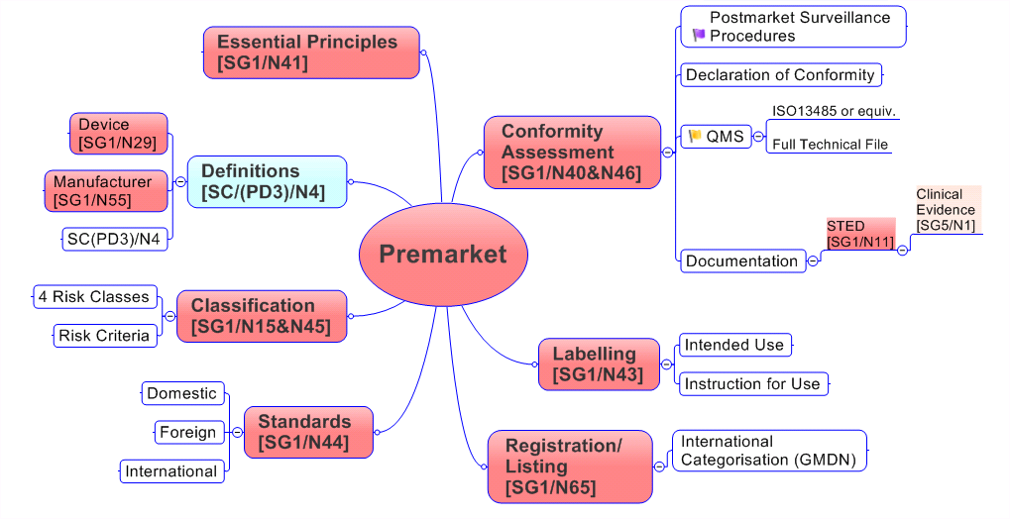

Post-market Surveillance/Vigilance
SG2 is charged with the task of developing harmonized manufacturers’ adverse event reporting and other forms of post-market surveillance for countries with existing medical device regulations and those countries in the process of developing medical device reporting regulations.
Significant elements of post-market surveillance/ vigilance involve information collection and assessment, risk analysis, decision / implementation, and safety information distribution as depicted in Figure 8.
By devising and agreeing upon a common reporting data set from manufacturers to the National Competent Authorities and the sharing of safety information by the National Competent Authorities Report (NCAR) exchange program, SG2 has and continues to enhance surveillance, evaluation, and the dissemination of information involving device safety on an international scale. These activities are also important contributors to risk management, quality management systems, and continual improvement throughout the medical device product life cycle.

Figure 8. Study Group 2 Documents and Links to International Standards

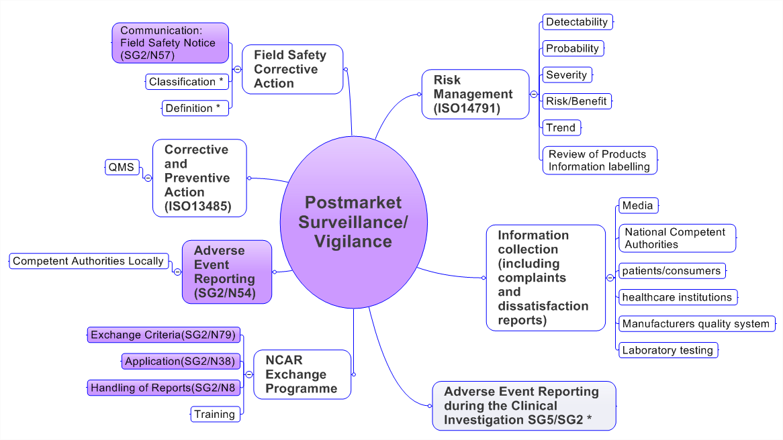* Under development

Quality Systems
SG3 is responsible for the task of examining existing quality system requirements in countries having developed device regulatory systems and identifying areas suitable for harmonization. Figure 9 illustrates some of the harmonized principles for a Quality Management System as addressed by SG3.

Figure 9. Study Group 3 Documents¹

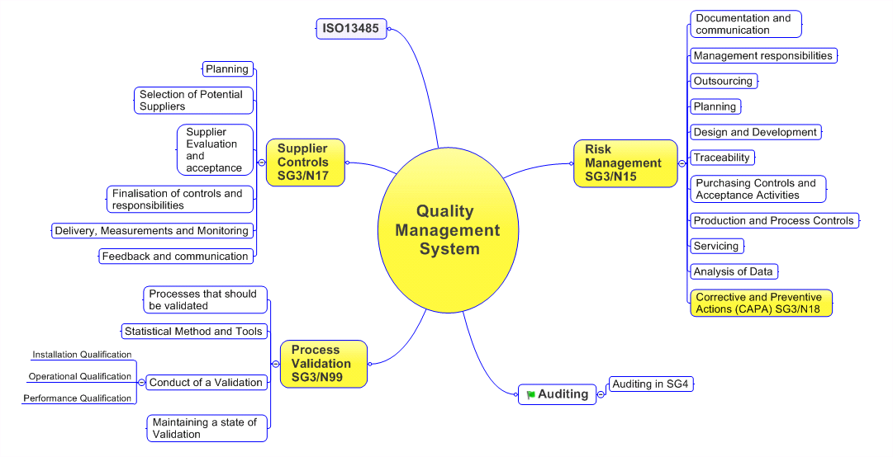
¹ Note that SG3 has worked closely with ISO TC 210 in the development of the ISO 13485 Quality Management System standard which offers the foundation for the management model supported by GHTF.

Auditing
SG4 was charged with examining quality system auditing practices (initially among the Founding Members of the GHTF) and developing guidance documents laying harmonized principles for the medical device auditing process. Figure 10 illustrates the harmonized principles as addressed by Study Group 4.

Figure 10. Study Group 4 Documents

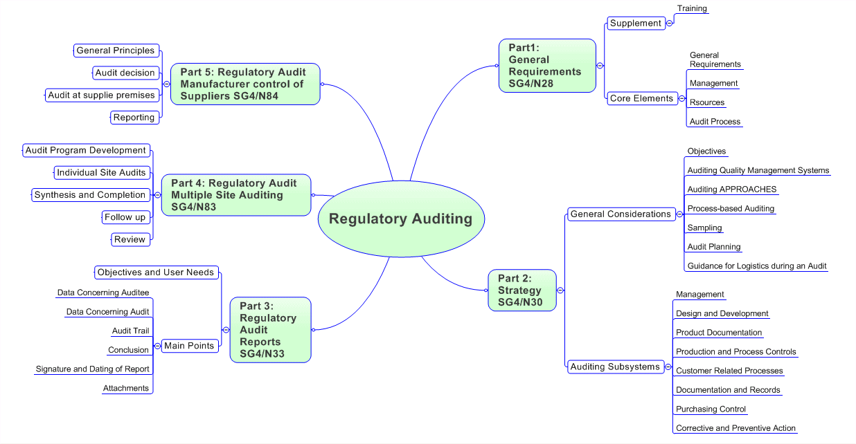

Clinical Safety/Performance
SG5 is charged with promoting convergence of regulatory requirements for evidence of the clinical safety and performance of medical devices. The group concentrates on establishing harmonized definitions for commonly used terms as well as developing harmonized guidance on the design and conduct of clinical investigations and on how to conduct and document a clinical evaluation. The group works closely with other GHTF study groups to review existing documents to ensure that terminology is consistent and interfaces are clear and that there is a consistent approach to broader GHTF initiatives. Figure 11 illustrates the harmonized principles addressed by Study Group 5.

Figure 11. Study Group 5 Documents

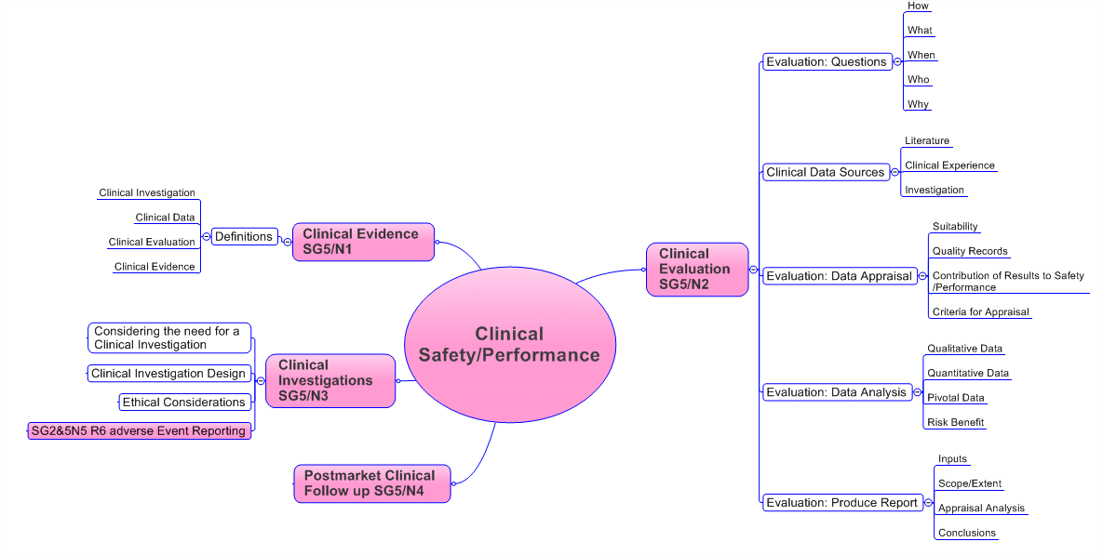

The GHTF Regulatory Model Dynamics and Interrelationships
The five major component parts of the GHTF model described in Section 10 are interrelated and the life-cycle is dynamic.
The parts are interrelated in that many requirements are connected. For example, the technical file described in Study Group 1 documents is also an aspect, and is one part of the output from the operation, of the Quality Management System. Clinical records created using Study Group 5 documents are maintained as directed under the Quality Management System.
The life cycle is dynamic in that an event occurring in any point of the life cycle may have a regulatory effect on other points in the cycle. For example, a defective product is detected and reported as described in Study Group 2 documents and corrective and preventive actions are taken as described in Study Group 1 and 3 documents.
Some of these interrelationships are described in the Study Group documents. For example, see the following:
- SG3/N99-10:2004 Quality Management Systems – Process Validation Guidance, Section 6. Maintaining a state of validation
- SG3/N15R8 Implementation of Risk Management Principles and activities within a Quality Management System, Section 7.7, Control of design and development changes; Section 13, Corrective and Preventive Actions
- SG3/N17:2008 Quality Management System – Medical Devices – Guidance on the Control of Products and Services Obtained from Suppliers, Section 3.5, Delivery, Measurement and Monitoring; Section 3.6, Feedback and communication
- SG1/N40:2006 Principles of Conformity Assessment for Medical Devices, Section 5.1.2 System for Post-market Surveillance, Section 6.3, Conformity assessment considerations
The GHTF is working to provide additional guidance on field corrective actions and on regulatory processes to address changes to products.
Figure 12 illustrates some of the interrelationships among the GHTF guidance documents.

Figure 12 Examples of GHTF Model Interrelationships
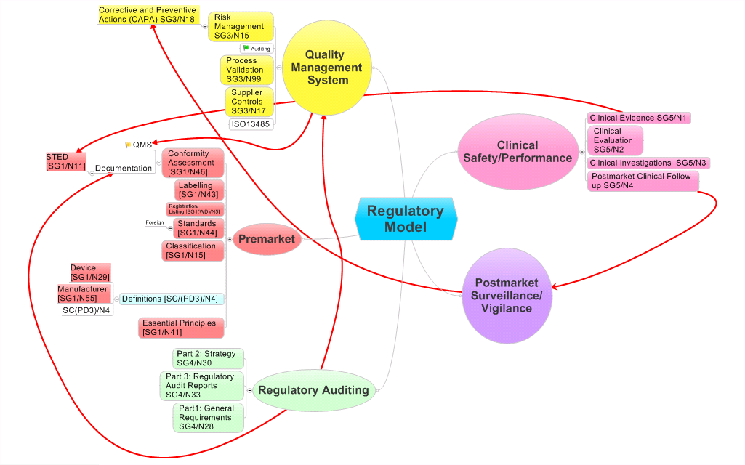
- Clinical Evidence is linked to the STED and supports the conformance to the Essential Principles
- The QMS is also required as part of the Conformity Assessment
- Postmarket Clinical Follow-up is part of Post-market Surveillance which as appropriate feeds into the Corrective and Preventive Action System
- Auditing is in many cases required of the QMS and also the documentation system and the design dossier and STED

Outline of Progressive Implementation of Elements of the GHTF Regulatory Model
This section sets out the suggested components of regulatory frameworks in a progressive manner depending on the desired level of implementation of the GHTF Regulatory Model (Figure 13).
As with any regulatory system, implementation of the GHTF regulatory model must be based upon a comprehensive legislative and policy foundation.
The suggested components presented below are intended to provide the reader with a high level view of what should be considered in developing a regulatory framework that would work for their specific policy priorities, needs, and resources. It should be noted that the suggested frameworks only refer to the elements of the GHTF Regulatory Model, and do not include other regulatory issues pertaining to medical devices such as use and disposal. Elements such as these are outside the scope of the GHTF. It should also be noted that the possible effect on the availability medical devices due to a burden of implemented regulations on manufacturers of medical devices is outside the scope of the GHTF.
Figure 13. Progressive Regulatory Framework

Basic level framework:
• Statement of policy considerations in establishing a regulatory frame: least burdensome approach, harmonization, transparency, political accountability, protection of the public, and administrative efficiency
• Acceptance of risk-based approach and classification system
• Adoption of elemental definitions including manufacturer, importer, distributor, medical device
• Establishment and maintenance of a “registry” listing of products being placed on the national/regional market with the contact information for the manufacturer (including regulatory contact) and recognized importers and distributers
• Establishment of a basic but active post-market surveillance system with incident reporting – possible involvement with NCAR
• Device manufacture under a Quality Management System which, as appropriate according to product risk class, is certified by a conformity assessment body (CAB) accepted by the jurisdiction. The CAB could be local or that of an external jurisdiction – e.g. Notified Bodies in the EU, Registrars in Canada, USFDA Accredited Persons in the USA or TGA in Australia or Registered Certification Bodies in Japan
• Approval of translated labeling material
• Good record keeping and documentation

Medium level framework:
- Demonstration of compliance with essential principles of safety and performance accepted through demonstration of market authorization by at least 1 respected regulatory authority (method of recognition to be decided upon by the country in question) – no additional requirements or review
- Mechanism for recognition of international standards
- Oversight of clinical trials to be done in the country – by regulatory authority, by delegation to CABs, etc.
- Approval for release of products not approved in other jurisdictions – e.g. similar to Canada’s Special Access Program
- Control of advertising and promotion

Highest level framework:
• Requirement for and detailed review of technical information by individual country, affiliation of countries or organization for multiple jurisdictions through international agreement (there can be various levels of detail of review identified depending on the risk class of the device)
• Robust review of clinical trial applications and post-trial review of results
• Oversight of conformity assessment of the manufacturer's QMS (there can be various levels of oversight)
• Increased robustness of the post-market surveillance system including a strong inspection program (there can be various levels of activities)
• Establishment of a post-market testing ability – e.g. appropriate mixture of dedicated laboratory and contracting out of testing to accredited labs
While the Basic Level Framework components should be considered to be the minimum requirements for a regulatory framework, additional elements from the medium and high level versions of the Model could be added based on need for regulatory oversight or resource availability. In efforts to establish the most robust framework possible, individual countries may wish to consider partnering with other countries. Similarly, all elements of the basic level framework are presumed to be incorporated in the medium and highest level frameworks.

References
GHTF final documents
Note that for readability the GHTF prefix and the year of issue of all document identifiers have been removed. Citations are correct at the time of publication of this document, but guidance documents are subject to periodic revisions. Current documents are available from the GHTF website.

SG1
SG1/N11 Summary Technical Documentation for Demonstrating Conformity to the Essential Principles of Safety and Performance of Medical Devices (STED)
SG1/N15: Principles of Medical Devices Classification.
SG1/N29: Information Document Concerning the Definition of the Term ‘Medical Device’.
SG1/N40 Principles of Conformity Assessment for Medical Devices
SG1/N41: Essential Principles of Safety and Performance of Medical Devices.
SG1/N43: Labelling for Medical Devices.
SG1/N44: Role of Standards in the Assessment of Medical Devices.
SG1/N45: Principles of In Vitro Diagnostic (IVD) Medical Devices Classification
SG1/N46: Principles of Conformity Assessment for In Vitro Diagnostic (IVD) Medical Devices
SG1/N55: Definitions of the Terms Manufacturer Authorised Representative, Distributor and Importer.
SG1/N65 Registration of Manufacturers and other Parties and Listing of Medical Devices

SG2
SG2/N8: Guidance on How to Handle Information Concerning Vigilance Reporting Related to Medical Devices
SG2/N38: Application Requirements for Participation in the GHTF National Competent Authority Report Exchange Program
SG2/N47: Review of Current Requirements on Postmarket Surveillance
SG2/N54: Medical Devices Post Market Surveillance: Global Guidance for Adverse Event Reporting for Medical Devices
SG2/N57: Medical Devices Post Market Surveillance: Content of Field Safety Notices
SG2/N79: Medical Devices: Post Market Surveillance: National Competent Authority Report Exchange Criteria and Report Form

SG3
SG3/N15: Implementation of Risk Management Principles and Activities Within a Quality Management System
SG3/N17: Quality Management System – Medical Devices – Guidance on the Control of Products and Services Obtained from Suppliers
SG3/N18 Guidance Quality management system-Medical Devices- Guidance on corrective action and preventive action and related QMS process
SG3/N99 Quality Management Systems - Process Validation Guidance

SG4
SG4 N28: Guidelines for Regulatory Auditing of Quality Systems of Medical Device Manufacturers - Part 1: General Requirements
SG4/N30: Guidelines for Regulatory Auditing of Quality Management Systems of Medical Device Manufacturers – Part 2: Regulatory Auditing Strategy
SG4/N33: Guidelines for Regulatory Auditing of Quality Management Systems of Medical Device Manufacturers – Part 3: Regulatory Audit Reports
SG4 (00) 3 Training Requirements for Auditors (Guidelines for Regulatory Auditing of Quality Systems of Medical Device Manufacturers - Part 1: General Requirements - Supplement 2)
SG4/N83: Guidelines for Regulatory Auditing of Quality Management Systems of Medical Device Manufacturers –
SG4/N84 Guidance Guidelines for Regulatory Auditing of Quality Management Systems of Medical Device Manufacturers

SG5
SG5/N1: Clinical Evidence – Key Definitions and Concepts
SG5/N2: Clinical Evaluation
SG5/N3 Clinical Investigations
SG5/N4 Post Market Clinical Follow-Up Studies

ISO Standards
ISO 9000: and 2008: Quality Management Systems - Fundamentals and Vocabulary
ISO 13485: Medical Devices- Quality management Systems – Requirements for Regulatory purposes
ISO 14971: Medical Devices – Application of risk management to medical devices

This document, entitled Overview of the GHTF Work Programme, was developed by Study Group 1 (identified as N31R1). At the 2nd meeting of the Ad Hoc Procedures Group in February, 2000, it was decided that this document could be of great value in educating those not that familiar with the work of GHTF as to the scope of work of each Study Group
See http://www.ghtf.org/sg2/sg2-guidance/index.html
The term “economy” is generally used in GHTF documents to describe a jurisdiction. The term is also used by the Asian Harmonization Working Party in its documents, including the terms of reference (See http://www.ahwp.info)
A mind map is a diagram used to represent tasks, ideas and documents linked to and arranged around a central key word or idea. Mind maps are used to generate, visualize, structure, and classify ideas, and are an aid in organization, problem solving, and decision making. The elements of a given mind map are arranged intuitively according to the importance of the concepts, and are classified into groupings or branches with the goal of representing connections between portions of information.

