Global Model Number (GMN)

全球型号代码

The Global Model Number is a GS1 key used to identify a product model or product family.

全球型号代码是用于标识产品型号或产品系列的GS1关键。

The Global Model Number enables companies to uniquely identify the product model through the entire life cycle of the product: design - production – procurement – use – maintenance - disposal.

全球型号代码可以使公司在产品的整个生命周期中唯一地标识产品型号：设计-生产–采购–使用–维护–处置。

Certain types of products require communication with trading partners and other stakeholders such as regulators before the product is actually taken into production. Furthermore, different products may be brought to the market based on the same technical product specification. That is why it can be of interest to group them under a same model or family, using a GMN.

特定类型的产品需要在实际投入生产之前，与贸易伙伴和其他利益相关者（例如监管者）进行沟通。此外，可能有基于相同技术的产品规格的不同产品会推向市场。这就是为什么使用GMN将它们归为同一型号或系列可能会引起人们的兴趣。

Examples include products that are sold under different versions, with different colors or supporting languages, but otherwise technically are the same.

示例包括以不同版本、不同颜色或支持语言出售的产品，但在技术上其他方面是相同的。

Other examples include medical devices, for which conformity assessment can take considerable time and effort before a product can be released on a market.

其他示例包括医疗器械，对其进行合格性评估可能需要花费大量时间和精力才能将产品投放市场。

In the European Union (EU), the GMN supports the implementation of the requirements of the **Basic UDI-DI** under the **EU Unique Device Identification (UDI) regulations** on medical devices and on in vitro diagnostic medical devices. The Basic UDI-DI is the main key for medical devices records in the UDI regulatory database EUDAMED and is referenced in relevant certificates and in EU declarations of conformity.

在欧盟（EU）中，GMN支持根据针对医疗器械和体外诊断医疗器械的**欧盟唯一设备标识（UDI）法规**来实施**基本UDI-DI**的要求。基本UDI-DI是UDI监管数据库EUDAMED中医疗器械记录的主要关键字，并且在相关证书和欧盟符合性声明中都有提及。

Please note that the **Basic UDI-DI (GMN) has a maximum length of 25 characters, including two mandatory check characters**. These can be calculated thanks to the [GS1 check character calculator dedicated webpage](https://www.gs1.org/services/gmn-generator).

请注意，**基本UDI-DI（GMN）的最大长度为25个字符，其中包括两个强制性的校验字符**。[借助GS1校验字符计算器专用网页，可以计算这些值](https://www.gs1.org/services/gmn-generator)。

**NOTE:** The GMN will initially be used for the identification of product model or product family for regulated medical devices in the European Union.

**注意：**GMN最初将用于识别欧盟受管制医疗器械的产品型号或产品系列。

**The Basic UDI-DI (GMN) SHALL NOT be encoded in a data carrier. The regulated medical device UDI-DI (GTIN) SHALL NOT be used as a replacement for Basic UDI-DI (GMN).**

**基本UDI-DI（GMN）不得在数据载体中编码。受管制的医疗器械UDI-DI（GTIN）不得替代基本UDI-DI（GMN）。**

Other applications may be added in the future, after approval through the GS1 Standards Management Process (GSMP).

将来如需添加其他应用程序，必须先经过GS1标准管理流程（GSMP）批准。

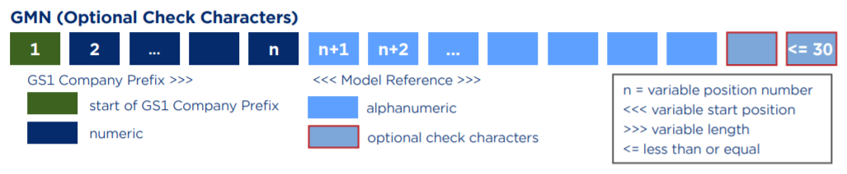

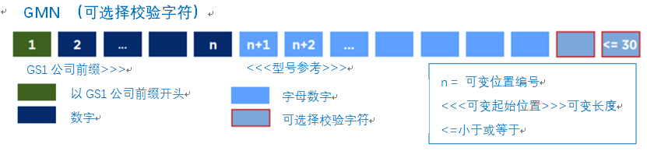

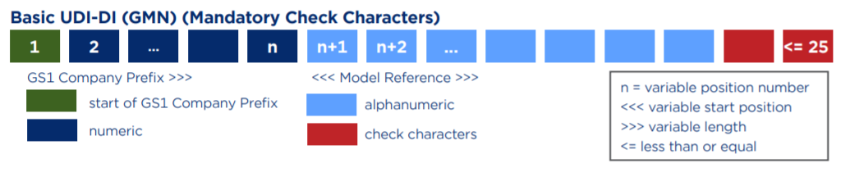

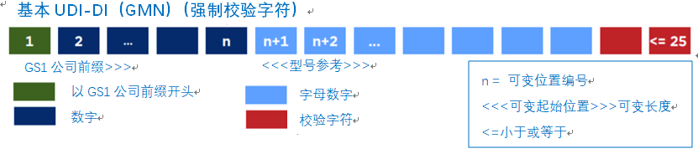

可调整配图

**GMN （可选择校验字符）**

GS1公司前缀>>>

<<<型号参考>>>

n = 可变位置编号

<<<可变起始位置>>>可变长度

<=小于或等于

字母数字

可选择校验字符

数字

以GS1公司前缀开头

C:\Users\w\AppData\Local\Temp\1597583702(1).png



**基本UDI-DI（GMN）（强制校验字符）**

GS1公司前缀>>>

<<<型号参考>>>

n = 可变位置编号

<<<可变起始位置>>>可变长度

<=小于或等于

字母数字

校验字符

数字

以GS1公司前缀开头

C:\Users\w\AppData\Local\Temp\1597584193(1).png



