**Clinical Evaluation Report**

**Clinical Evaluation according to MEDDEV 2.7.1 rev.4 and Regulation(EU)2017/745**

**Product Name:** **{产品名称}**

***【本处填写产品名称，需要确保全篇技术文档及报告等的名称一致】***

**Model:** **{产品型号1}、{产品型号2}、{产品型号N}**

***【需要罗列本次认证的所有产品型号清单，如型号很多，可以采用另外附件文档的方式给出】***

**Document No.:** **{文件编号}**

***【本处填写本文件的编号】***

**Edition: {文件版本}**

***【本处填写本文件的版本】***

**Approved by:**

**Audited by:**

**Applied by：**

{XXXX公司}

**Revision records:**

|  |  |  |  |  |  |
| --- | --- | --- | --- | --- | --- |
| **Edition** | **Effective Date** | **Summary of revision** | **Drafted by** | **Checked by** | **Approved by** |
| {文件版本1} | {年-月-日} | First release | {XX名字} | {XX名字} | {XX名字} |
| {文件版本2} | {年-月-日} | {本版本相对上一版本版本更新了****，主要原因是****, 涉及到修改的小节是*****}  *【填写本技术文档的版本相对于上一版本更新了哪些内容？为什么更新？以及更新内容具体的地方及小节编号？】* | {XX名字} | {XX名字} | {XX名字} |
| {文件版本N} | {年-月-日} | {本版本相对上一版本版本更新了****，主要原因是****, 涉及到修改的小节是*****}  *【填写本技术文档的版本相对于上一版本更新了哪些内容？为什么更新？以及更新内容具体的地方及小节编号？】* | {XX名字} | {XX名字} | {XX名字} |
|  |  |  |  |  |  |
|  |  |  |  |  |  |
|  |  |  |  |  |  |
|  |  |  |  |  |  |
|  |  |  |  |  |  |
|  |  |  |  |  |  |
|  |  |  |  |  |  |
|  |  |  |  |  |  |
|  |  |  |  |  |  |
|  |  |  |  |  |  |

Contents

1. Summary 7

1.1 General details 7

1.2 Introduce of Clinical evaluation 7

1.3 Summary of the clinical evaluation 7

2. Scope of the clinical evaluation 8

2.1 General principles of clinical evaluation 8

2.1.1 Clinical evaluation objectives 8

2.1.2 Scope of clinical evaluation 9

2.1.3 Stages of clinical evaluation 9

2.2 Identification of devices covered by this clinical evaluation report 11

2.2.1 Device description 11

2.2.2 Company Introduction 16

2.3 Whether this clinical evaluation is submitted to the MDR as amended by Regulation(EU) 2017/745 17

2.4 picture or drawing of the device 17

2.5 Technologies used, whether the device is based on a new technology, a new clinical application of an existing technology, or the result of incremental change of an existing technology. Description of innovative aspects of the device 17

2.6 Changes since the last report 17

2.7 Product Classification 17

2.8 Conformity assessment Route 17

3. Clinical background, current knowledge, state of the art 17

3.1. Identification of medical fields concerned/ relevant medical conditions 17

3.2 Brief summary and justification of literature search strategy 18

3.3 Appraisal criteria used 18

3.4 Applicable standards and guidance documents 19

3.5 Description, natural course and consequences of the medical conditions concerned 20

3.6 Summary of advantages and disadvantages of the different options and benefit/risk profiles 20

3.7 Hazards due to substances and technologies that could be relevant to the device under evaluation 21

3.8 Types of users 21

4. Device under evaluation 21

4.1. Type of evaluation 21

4.1.1 Outline how these considerations were used to choose the types of clinical data used for the evaluation 21

4.2. Demonstration of equivalence 22

4.2.1 Identification of the equivalent device and its manufacturer 22

4.2.2 Comparison of clinical, biological and technical characteristics 23

4.2.3 Identification and evaluation of pre-clinical studies carried out and literature used 29

4.2.4 Comparative tabulations for the device under evaluation versus the equivalent device 29

4.2.5 Identification of differences between device under evaluation and equivalent device 29

4.2.6 Conclusions concerning equivalence 29

4.2.7 Conclusions whether equivalence is demonstrated or not 29

4.3. Clinical data generated and held by the manufacturer 30

4.3.1 All pre market clinical investigations 30

4.3.2 Clinical data generated from risk management activities and PMS programmes 30

4.3.3 Relevant pre-clinical studies 31

4.4. Clinical data from literature 31

4.5. Summary and appraisal of clinical data 32

4.5.1 Summary of the clinical data 32

4.5.2. The appraisal plan 32

4.5.3 Conduct of the appraisal 32

4.6. Analysis of the clinical data 38

4.6.1. Requirement on safety(MDR ER4) 38

4.6.2. Requirement on acceptable benefit/risk profile (MDR ER2) 38

4.6.3. Requirement on performance(MDR ER1) 38

4.6.4. Requirement on acceptability of side-effects (MDR ER8) 38

5. Conclusion 38

6. Date of the next clinical evaluation 39

6.1 Suggested date 39

6.2 Justification of the date 40

7. Dates and signatures 41

7.1 The clinical evaluation team 41

7.2 Date and signatures of the evaluators 41

8. Qualification of the responsible evaluators 42

9. References 43

10. Annex 43

*10.1 Annex 1- CV of evaluators* 43

*10.2 Annex 2- Literature Search Protocol and Report* 43

*10.3 Annex 3-CV of searcher* 43

*10.4 Annex 4-The literatures used for analysis* 43

*10.5 Annex 5-Clinical evaluation checklist* 43

*10.6 Annex 6-Declaration of Interests* 43

*10.7 Annex 7-CE Certificate of Equivalent devices* 43

*10.8 Annex 8-Clinical Evaluation Plan* 43

*10.9 Annex 8-Clinical investigation report）* 43

1. **Summary**

## **1.1 General details**

Device name: **{产品名称}**

Device model: **{产品型号1}、{产品型号2}、{产品型号N}**

***【需要罗列本次认证的所有产品型号清单，如型号很多，可以采用另外附件文档的方式给出】***

Manufacturer:**{生产商}**

Address:**{生产商地址}**

Website: **{生产商网站}**

## **1.2 Introduce of Clinical evaluation**

**{填入临床评价的基本介绍}**

*（参考示例:*

*This report applies to the {产品名称}produced by {生产商} . It’s evaluated according to MEDDEV.2.7.1 Rev.4 and Regulation(EU)2017/745 Article 61 Clinical evaluation and Annex XIV Clinical evaluation and post-market clinical follow-up. Through assessing relevant clinical literature data, performance tests, pre-clinical data, post-market surveillance, experience data, etc. This report is to evaluate the safety and effectiveness, potential risks and side effects in the clinical application of {产品名称} ）*

## **1.3 Summary of the clinical evaluation**

**{填入临床评价的概要总结}**

***【本节建议概述确定预期目标人群和医用适应症的的受益/风险特征的说明，并表明基于相关医学领域的当前技术水平下受益/风险特征的可接受性。】***

*（参考示例:*

*The purpose of this document is to evaluate clinical data from pre-clinical data, scientific literature and clinical experience to establish conformity of the {产品名称} with the pertinent clinically-based essential requirements of the Regulation(EU)2017/745 and the guidance in MEDDEV 2.7/1 rev 4.*

*Before carried out the clinical evaluation, we defined the scope of the clinical evaluation. For clinical evaluation, we choose the products, {对比产品名称} produced by {对比产品生产商}, {对比产品名称}produced by {对比产品生产商} as equivalence devices, which have been put on market and been used widely, then searched the clinical data though different ways, such as: pre-clinical evaluation, scientific literature, clinical experience etc. After appraisal and analysis of those clinical data of device under evaluation, equivalence devices and similar device, Then we combine the result of above factors to conduct risk management according to EN ISO 14971：2018, identified the risks mentioned in the clinical data from the aspects of safety and performance. For those risks and risks related to the customer complication , adverse events, recall, etc, measures were taken to lower them to an acceptable level. Considering the benefit/risk analysis, all of the risks are accepted after we evaluate those risks in the Risk Management Report. Finally, it was demonstrated that our device is safe and effective. We summarize the determination of the benefit/risk profile in the intended target groups and medical indications. The benefits outweight the risks. And the acceptability of benefit/risk profile had been demonstrated based on the state of the art in the medical fields concerned.*

*In conclusion, {产品名称} , complies with Regulation(EU)2017/745 Article 61 Clinical evaluation and Annex XIV Clinical evaluation and post-market clinical follow-up and conform to the Regulation(EU)2017/745 essential requirements when used under the conditions and for the purposes intended by the manufacturer.）*

1. **Scope of the clinical evaluation**

**2.1** **General principles of clinical evaluation**

**2.1.1 Clinical evaluation objectives**

**{填入临床评价的目的}**

*（参考示例:*

*To demonstrate {产品名称} have achieving its intended use and performance during normal conditions of use and that the known and foreseeable risks, and any adverse events are minimised and acceptable when weighed against the benefits of the intended performance, and that any claims made about the device’s performance and safety are supported by suitable evidence.）*

**2.1.2 Scope of clinical evaluation**

**{填入临床评价的范围}**

*（参考示例:*

*1) Intended purpose and application of the device;*

*2) Manufacturer’s specific claims about clinical performance and safety of device;*

*3) The significance of any risks that remain;*

*4) The data source and type of data to be used in the clinical evaluation.*

*5) Products/ models/ sizes/ settings and the technology on which the medical device is based.）*

**2.1.3 Stages of clinical evaluation**

**{填入临床评价的阶段介绍}**

*（参考示例:*

*The clinical evaluation is based on a comprehensive analysis of available pre- and post-market clinical data relevant to the intended purpose of the device in question, including clinical performance data and clinical safety data.*

*There are discrete stages in performing a clinical evaluation:*

*• Stage 0: Define the scope, plan the clinical evaluation (also referred to as scoping and the clinical evaluation plan).*

*• Stage 1: Identify pertinent data.*

*• Stage 2: Appraise each individual data set, in terms of its scientific validity, relevance and weighting.*

*• Stage 3: Analyse the data, whereby conclusions are reached about*

*- compliance with Essential Requirements on performance and safety of the device, including its benefit/risk profile,*

*- the contents of information materials supplied by the manufacturer (including the label, IFU of the device, available promotional materials, including accompanying documents possibly foreseen by the manufacturer),*

*- residual risks and uncertainties or unanswered questions (including on rare complications, long term performance, safety under wide-spread use), whether these are acceptable for CE-marking, and whether they are required to be addressed during PMS.*

*• Stage 4: Finalize the clinical evaluation report*

*The clinical evaluation report summarizes and draws together the evaluation of all the relevant clinical data documented or referenced in other parts of the technical documentation. The clinical evaluation report and the relevant clinical data constitute the clinical evidence for conformity assessment.*

*Each of these stages is conducted according to the relevant section of the MEDDEV 2.7/1 rev 4 (see the figure below):*

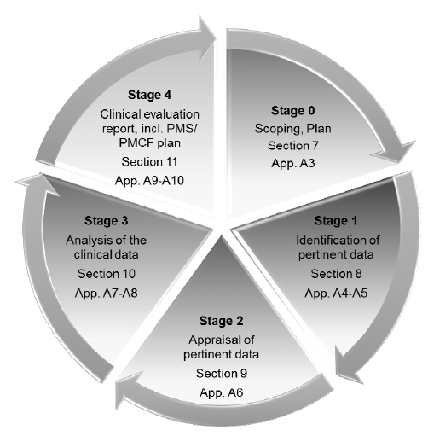

*Figure 1: Stages of a clinical evaluation and references to sections and appendices of MEDDEV 2.7/1 rev 4）*

**2.2 Identification of devices covered by this clinical evaluation report**

**2.2.1 Device description**

The following content is provided according to Appendix A3 of MEDDEV 2.7.1 rev.4.

**2.2.1.1 Product Name**

**{产品名称}**

**2.2.1.2 Models**

Device model: **{产品型号}**

The differences between modes : **{产品型号之间的差异}**

|  |  |  |  |
| --- | --- | --- | --- |
| **type** | **Model 1** | **Model 2** | **Model \*\*** |
| Different 1 | ***【根据实际情况填写】*** | ***【根据实际情况填写】*** | ***【根据实际情况填写】*** |
| Different 2 | ***【根据实际情况填写】*** | ***【根据实际情况填写】*** | ***【根据实际情况填写】*** |
| Different 3 | ***【根据实际情况填写】*** | ***【根据实际情况填写】*** | ***【根据实际情况填写】*** |
| Different ** | ***【根据实际情况填写】*** | ***【根据实际情况填写】*** | ***【根据实际情况填写】*** |

**2.2.1.3 sizes**

**{尺寸}**

**2.2.1.4 Components of the device, including software and accessories**

**{描述产品的组成，包括软件和附件}**

***【描述产品的主要构成，如可以，尽量详细，并提供各构成组件的实物图、工程图、爆炸图等；***

***以及如果有软件及附件，需要对软件的功能，以及各附件的构成、作用、功能及图示等进行描述】***

**2.2.1.5** **device group to which the device belongs**

**{描述器械归属的器械组}**

*（参考示例:*

*The device do not belongs to any device group.*

*And the device does not contain added drugs such as antimicrobial agents, added biologics such as growth factors, or is composed of materials derived from animal sources.）*

**2.2.1.6 whether the device is being developed/ undergoing initial CE-marking/ is CE-marked**

**{描述器械是否获得CE认证}**

*（参考示例:*

*The device is being undergoing initial CE-marking, and is not CE-marked. ）*

**2.2.1.7 whether the device is currently on the market in Europe or in other countries**

**{描述器械是否已经在欧盟或其他国家上市}**

***【如果产品已在欧盟或其他地方上市，需要说明上市的时间，以及销售数据的相关信息。***

***】***

*（参考示例:*

*The device is not currently on any market in Europe or in other countries. ）*

**2.2.1.8 intended purpose of the device**

**2.2.1.8.1 exact medical indications**

{填写医学适应症}

**2.2.1.8.2 name of disease or condition/ clinical form, stage, severity/ symptoms or aspects to be treated, managed or diagnosed**

**{**需要治疗、管理或诊断的疾病、条件/临床形式、阶段、严重程度/症状或方面的名称**}**

**2.2.1.8.3 patient populations**

{填写病人人群信息}

*（参考示例: adults / children / infant）*

**2.2.1.8.4 intended user**

{填写预期用户}

*（参考示例: use by health care professional / lay person）*

**2.2.1.8.5 organs / parts of the body / tissues or body fluids contacted by the device**

{器械接触的器官/身体组织或体液}

*（参考示例:The componts involved organs / parts of the body / tissues or body fluids contacted are following: {接触的器官/身体组织或体液的组件名称}.*

*The {接触的器官/身体组织或体液的组件名称}produces using {组件材料} materials met the standards {组件材料符合的标准，如有}*

*the style of patient contacting: According to EN ISO 10993-1, the the style of patient contacting for the device is following:*

*Category: External communicating device*

*Contact: Tissue*

*contact duration: Limited exposure (≤ 24 h)）*

***【需要根据产品实际的接触性质进行填写。如不涉及直接或间接接触，写NA】***

**2.2.1.8.6 duration of use or contact with the body**

{使用时间或接触时间}

**2.2.1.8.7 repeat applications, including any restrictions as to the number or duration of reapplications**

{重复使用，包括对重复使用的次数或持续时间的任何限制}

**2.2.1.8.8 Contact with mucosal membranes/ invasiveness/ implantation**

{描述是否接触粘膜、是否侵入、是否植入}

**2.2.1.8.9 Contraindications**

{禁忌症}

***【需要注意与说明书一致，如果可以,可以引用到说明书中的具体条款的内容，The contraindications provided by the manufacturer can be referred to IFU section **】***

**2.2.1.8.10 Precautions required by the manufacturer**

{预防措施}

***【需要注意与说明书一致，如果可以,可以引用到说明书中的具体条款的内容，The Precautions provided by the manufacturer can be referred to IFU section **】***

**2.2.1.8.11 Single use / reusable**

{单次使用/重复使用}

**2.2.1.8.12 invasive/****non invasive**

{是否无创/非无创}

**2.2.1.8.13 implantable**

{是否植入}

**2.2.1.8.14 other aspects**

{其他}

**2.2.1.9 general description of the medical device**

**2.2.1.9.1 A concise physical and chemical description**

{**简要描述的物理和化学特征**}

**2.2.1.9.2 technical specifications, mechanical characteristics**

**{描述技术规格、机械特征**}

**2.2.1.9.3 sterility**

{**无菌**}

***【如产品无菌或有无菌部件（含需要终端用户灭菌的情况)， 建议说明具体的名称以及灭菌方法、参数及工艺等相关信息。】***

**2.2.1.9.4 radioactivity**

{放射性}

**2.2.1.9.5 how the device achieves its intended purpose**

{该设备是如何实现其预期目的的}

**2.2.1.9.6 Principles of operation**

{操作原理}

**2.2.1.9.7 materials used in the device with focus on materials coming in contact (directly or indirectly) with the patient/ user, description of body parts concerned**

{器械接触的器官/身体组织或体液}

*（参考示例:The componts involved coming in contact (directly or indirectly) with the patient/ user following: {直接或间接接触病人/用户的组件名称}.*

*The {直接或间接接触病人/用户的组件名称} produces using {组件材料} materials met the standards {组件材料符合的标准，如有}*

*the style of patient contacting: According to EN ISO 10993-1, the the style of patient contacting for the device is following:*

*Category: External communicating device*

*Contact: Tissue*

*contact duration: Limited exposure (≤ 24 h)）*

***【需要根据产品实际的接触性质进行填写。如不涉及直接或间接接触，写NA】***

**2.2.1.9.8 whether it incorporates a medicinal substance (already on the market or new), animal tissues, or blood components, the purpose of the component**

{器械是否含有一种药物（已经在市场上或新的）、动物组织或血液成分，以及该成分的目的}

**2.2.1.9.9 other aspects**

{其他}

**2.2.1.10 whether the device is intended to cover medical needs that are otherwise unmet/ if there are medical alternatives to the device / if the device is equivalent to an existing device, with a description of the situation and any new features**

{器械是否旨在满足其他无法满足的医疗需求/是否该器械有医疗替代品/是否该器械等同于已有器械，描述这些情况以及任何新功能}

**2.2.1.11 if the device is intended to enter the market based on equivalence**

{器械是否预期基于等同性进入市场}

*（参考示例:The device is intended to enter the market based on equivalence. The device presumed to be equivalent is as below. The equivalence has been demonstrated and the specific information can refer to section 4.2 of the clinical evaluation report.*

|  |  |
| --- | --- |
| **Equivalent device 1** | Name: {等同器械名称}  Models: {等同器械型号}  Sizes: {等同器械尺寸}  components:{等同器械构成}  Software:{等同器械软件}  Accessories: {等同器械附件} |
| **Manufacturer** | {等同器械生产商} |
| **NB number** | {等同器械发证的CE公告机构编号} |
| **CE Certificate No.** | {等同器械的CE证书编号} |

|  |  |
| --- | --- |
| **Equivalent device N** | Name: {等同器械名称}  Models: {等同器械型号}  Sizes: {等同器械尺寸}  components:{等同器械构成}  Software:{等同器械软件}  Accessories: {等同器械附件} |
| **Manufacturer** | {等同器械生产商} |
| **NB number** | {等同器械发证的CE公告机构编号} |
| **CE Certificate No.** | {等同器械的CE证书编号} |

*）*

**2.2.1.12 Intended performance**

{预期的性能}

***【至少包含，比如technical performance，intended clinical benefits，claims regarding clinical performance and clinical safety 等】***

**2.2.1.13 For devices based on predecessor devices**

{器械是否基于前代器械}

***【如果是基于前代器械，至少包含前代器械的如下信息：***

***Name, Models, sizes, whether the predecessor device is still on the market, description of the modifications, date of the modifications】***

**2.2.1.14 The current version number or date of the information materials supplied by the manufacturer**

{制造商提供的信息材料的当前版本号或日期}

*（参考示例:*

*Label: V*{版本号} *, Effective date：****.**.\*\**{年月日}

*IFU: V*{版本号}*, Effective date：****.**.\*\**{年月日}

*promotional materials: V\*\**{版本号}*, Effective date：****.**.\*\**{年月日}

*accompanying documents: V\*\**{版本号}*, Effective date：****.**.\*\**{年月日}

*Other information materials supplied by the manufacturer: V\*\**{版本号}*, Effective date：****.**.\*\**{年月日}*）*

**2.2.2 Company Introduction**

**2.2.2.1 Manufacturer Information**

{生产商信息}

***【至少包含，比如Manufacturer，Address，Tel，Website 等】***

**2.2.2.2 Company Introduction**

{公司介绍}

**2.3 Whether this clinical evaluation is submitted to the MDR as amended by Regulation(EU) 2017/745**

{本临床评估是否依据MDR法规(EU)2017/745进行修订}

**2.4 picture or drawing of the device**

{设备的图片或图纸}

**2.5 Technologies used, whether the device is based on a new technology, a new clinical application of an existing technology, or the result of incremental change of an existing technology. Description of innovative aspects of the device**

{所使用的技术，器械是否基于新技术，是否是现有技术的新临床应用，或者是否是现有技术的增量变化的结果。描述该设备的创新方面的说明}

**2.6 Changes since the last report**

{对上一次报告的变更}

***【除描述本临床评价报告的变更外，如果适用的话，还需要说明：器械是否有变更，是否在新的临床评价报告中引入新的产品、型号、尺寸、软件、附件、新预期用途、新的声明、与器械影响相关的新的事件等等。如果有以上变更的话，需要识别相关修改信息在临床评价报告的具体章节和位置。】***

**2.7 Product Classification**

{产品分类}

***【描述依据MDR法规的产品分类以及依据的分类规则，以及该分类的理由的说明】***

**2.8 Conformity assessment Route**

{符合评估路径}

***【描述依据MDR法规的符合评估路径以及对应的MDR法规章节，以及采用该符合评估路径的理由的说明】***

1. **Clinical background, current knowledge, state of the art**

**3.1. Identification of medical fields concerned/ relevant medical conditions**

{识别相关医疗领域/相关医疗状况}

**3.2 Brief summary and justification of literature search strategy**

{对文献搜索策略的简要概述和理由说明}

*（参考示例:We make the literature search strategy according to Appendices A4-A5 of MEDDEV 2.7.1 rev.4, which including sources used, search questions, search terms, selection criteria applied to the output of the search, quality control measures, results, number and type of literature found to be pertinent.*

*These contents mentioned above can be referred to Annex 2 Literature search protocol and report.)*

**3.3 Appraisal criteria used**

{所使用的分析标准}

***【本处为对收集的文献及临床数据等的分析评价标准，需要结合实际情况制定】***

*（参考示例:*

*In the clinical evaluation, the Suitability and Contribution were evaluated for the clinical, the Appraisal Criteria is following:*

*Table 1: Appraisal Criteria for Suitability*

| *Suitability Criteria* | *Description* | *Grading System* |
| --- | --- | --- |
| *Appropriate device* | *Were the data generated from the device in question?* | *D1 Actual device*  *D2 Equivalent device*  *D3 Other device* |
| *Appropriate device application* | *Was the device used for the same intended use (e.g., methods of deployment, application, etc.)?* | *A1 Same use*  *A2 Minor deviation*  *A3 Major deviation* |
| *Appropriate patient group* | *Were the data generated from a patient group that is representative of the intended treatment population (e.g., age, sex, etc.) and clinical condition (i.e., disease, including state and severity)?* | *P1 Applicable*  *P2 Limited*  *P3 Different population* |
| *Acceptable report/data collation* | *Do the reports or collations of data contain sufficient information to be able to undertake a rational and objective assessment?* | *R1 High quality*  *R2 Minor deficiencies*  *R3 Insufficient information* |

*Table 2: Appraisal Criteria for Data Contribution*

| *Data Contribution Criteria* | *Description* | *Grading System* |
| --- | --- | --- |
| *Data source type* | *Was the design of the study appropriate?* | *T1 Yes*  *T2 No* |
| *Outcome measures* | *Do the outcome measures reported reflect the intended performance of the device?* | *O1 Yes*  *O2 No* |
| *Follow up* | *Is the duration of follow-up long enough to assess whether duration of treatment effects and identify complications?* | *F1 Yes*  *F2 No* |
| *Statistical significance* | *Has a statistical analysis of the data been provided and is it appropriate?* | *S1 Yes*  *S2 No* |
| *performance the device* | *Do the data address the performance of the device in question?* | *PE1 Yes*  *PE2 No* |
| *safety of the device* | *Do the data address the safety of the device in question?* | *SA1 Yes*  *SA2 No* |
| *Clinical significance* | *Was the magnitude of the treatment effect observed clinically significant?* | *C1 Yes*  *C2 No* |

*)*

**3.4 Applicable standards and guidance documents**

{适用的标准和指南文件}

***【本处为申报产品适用的标准及指南文件等】***

*（参考示例:*

*\*\*\*\* designed and produced by **** Co., Ltd. should meet the standards and guidance as blew:*

| *No.* | *Ref.* | *Reference and title of the harmonized standard (and reference document)* |
| --- | --- | --- |
| *1* | *Graphical*  *symbols* | *EN ISO 15223-1:2016*  *Medical devices -- Symbols to be used with medical device labels, labeling and information to be supplied -- Part 1: General requirements* |
| *2* | *Information*  *supplied* | *EN 1041:2008+AC:2013*  *Information supplied by the manufacturer of medical devices* |
| *3* | *Clinical*  *evaluation* | *MEDDEV. 2.7.1 Rev.4 Guidelines on medical devices evaluation of clinical data: a guide for manufacturers and Notified Bodies* |
| *4* | *PMS* | *MEDDEV. 2.12-2 Rev.2*  *Guidelines on medical devices of post market clinical follow-up studies: a guide for manufacturers and notified bodies* |
| *5* | *Vigilance*  *system* | *MEDDEV 2.12-1 rev 8  Guidelines on a medical devices vigilance system* |
| *6* | *usability* | *EN 62366-1:2015*  *Medical devices — Application of usability*  *engineering to medical devices* |
| *N* | *\*\*\** | *\*\*\*\*\** |

*)*

**3.5 Description, natural course and consequences of the medical conditions concerned**

{相关疾病的描述、发生过程和后果}

**3.6 Summary of advantages and disadvantages of the different options and benefit/risk profiles**

{不同选择的优缺点概述以及风险收益特征}

**3.7 Hazards due to substances and technologies that could be relevant to the device under evaluation**

{与被评估器械相关的物质和技术造成的危害}

**3.8 Types of users**

{用户类型}

1. **Device under evaluation**

**4.1. Type of evaluation**

### 4.1.1 Outline how these considerations were used to choose the types of clinical data used for the evaluation

{概述如何使用这些考虑因素来选择用于评估的临床数据的类型}

*（参考示例:*

*The type of clinical data used in this clinical evaluation is generated through below:*

*1)literature search*

*2)clinical experience*

*Demonstration of conformity with essential requirements based on clinical data is deemed appropriate.*

*Factors that have been considered when choosing the type of data to be used in the clinical evaluation include :*

*the design, intended use and risks of the device;*

*the developmental context of the technology on which the device is based*

*the proposed clinical application of the established technology*

*Because the technology of the device under evaluation is a long standing technology. So after considering the above three factors, Clinical evaluation of devices can be based on existing, well established technologies and intended for an established use of the technology. So Clinical evaluation of devices can be mostly likely to rely on compliance with recognised standards and/or literature review and/or clinical experience of equivalent devices, The clinical experience includes the recalls and adverse events we have found among United State, United Kingdom and China.*

*So we choose clinical data generated from literature search and clinical experience of equivalent devices and choose the test reports compliance with recognized standards as a part of the data for supporting the Clinical evaluation.*

*What is more,* *the device under evaluation had been on the market for years, we collect the data gathering from post-market information as the data of clinical experience, such as adverse events, recall, ect.*

*So base on the above consideration, we draw on combination of data sources generated through literature search, clinical experience for evaluation. )*

**4.2. Demonstration of equivalence**

**4.2.1 Identification of the equivalent device and its manufacturer**

**Table 3 The list and basic information of equivalent device(s)**

{等同器械的清单及基本信息}

*（参考示例:*

|  |  |
| --- | --- |
| **Equivalent device 1** | Name: {等同器械名称}  Models: {等同器械型号}  Sizes: {等同器械尺寸}  components:{等同器械构成}  Software:{等同器械软件}  Accessories: {等同器械附件} |
| **Manufacturer** | {等同器械生产商} |
| **NB number** | {等同器械发证的CE公告机构编号} |
| **CE Certificate No.** | {等同器械的CE证书编号} |

|  |  |
| --- | --- |
| **Equivalent device N** | Name: {等同器械名称}  Models: {等同器械型号}  Sizes: {等同器械尺寸}  components:{等同器械构成}  Software:{等同器械软件}  Accessories: {等同器械附件} |
| **Manufacturer** | {等同器械生产商} |
| **NB number** | {等同器械发证的CE公告机构编号} |
| **CE Certificate No.** | {等同器械的CE证书编号} |

*)*

**4.2.2 Comparison of clinical, biological and technical characteristics**

{临床、生物、技术特征的比较}

***【本处为申报产品和选择的对比产品进行临床、生物、技术特征的比较，参考的主要法规为MEDDEV 2.7/1 REV 4 Appendix A1 以及MDCG 2020-5 Clinical Evaluation - Equivalence A guide for manufacturers and notified bodies (April 2020). 具体的比较项目需要结合实际情况制定】***

*（参考示例: 以下为等同比较的参考表格*

注释：需要根据实际的对比补充完整。表格示例供参考。

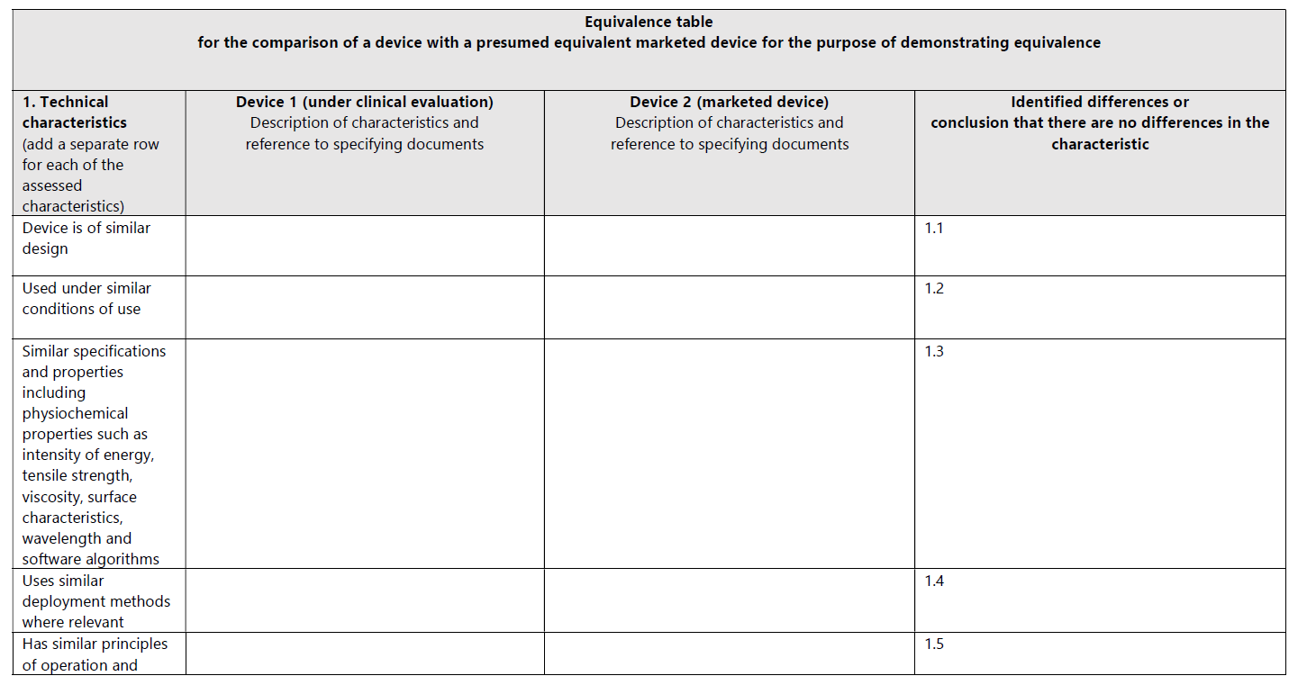

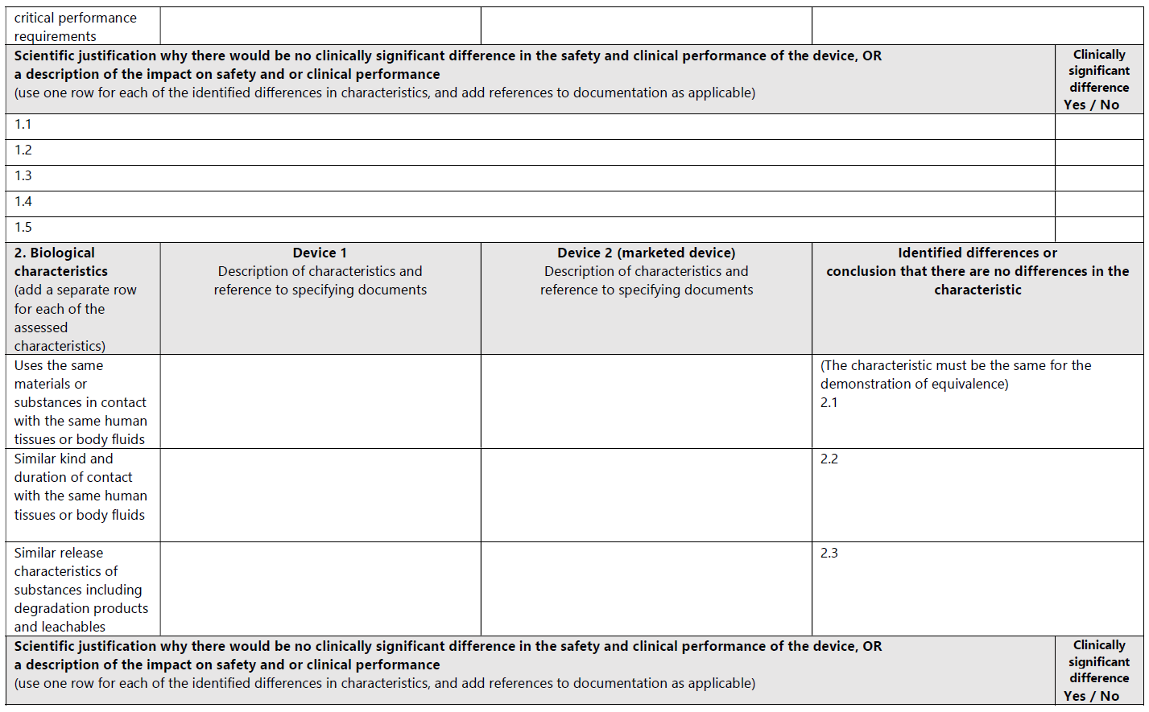

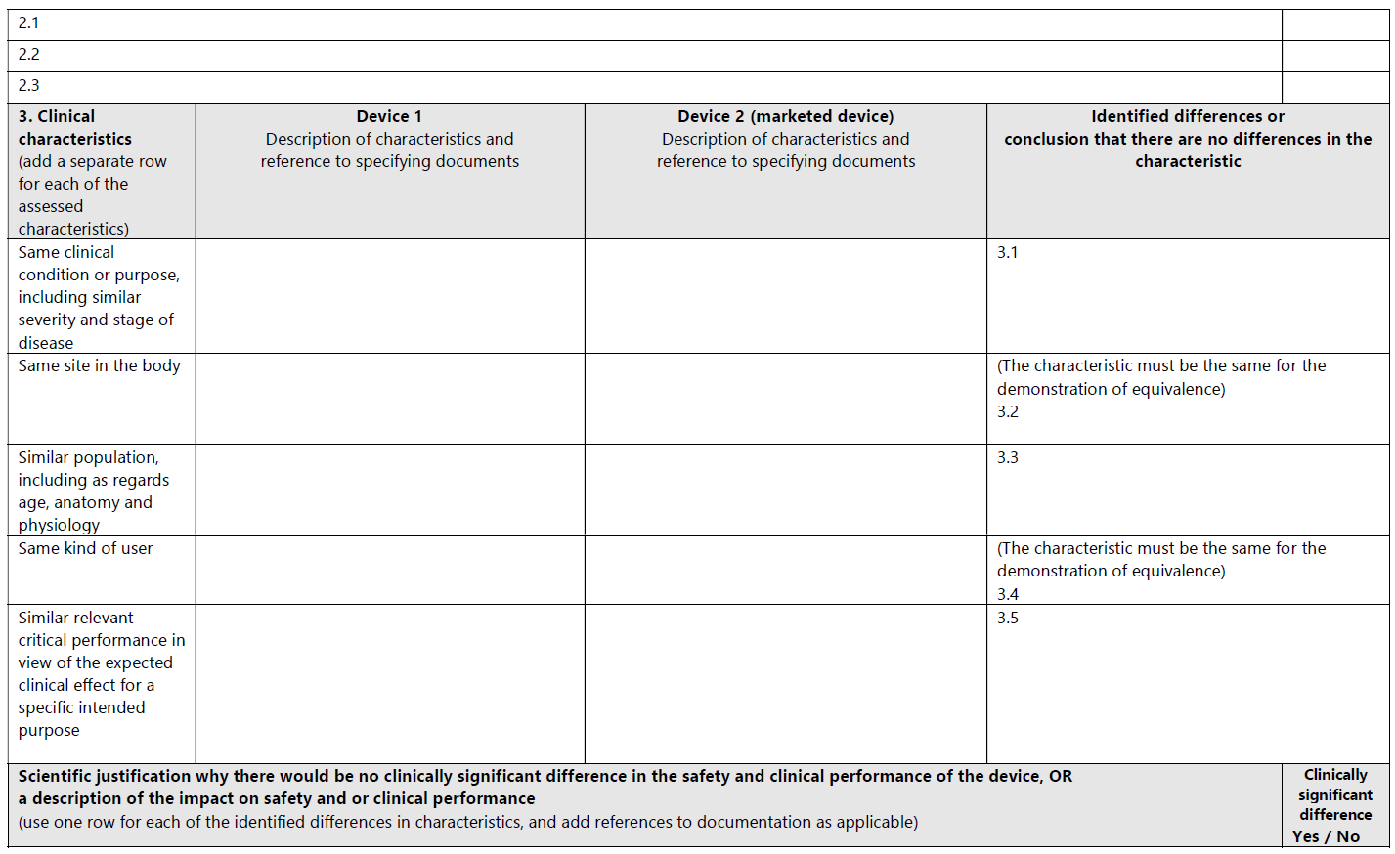

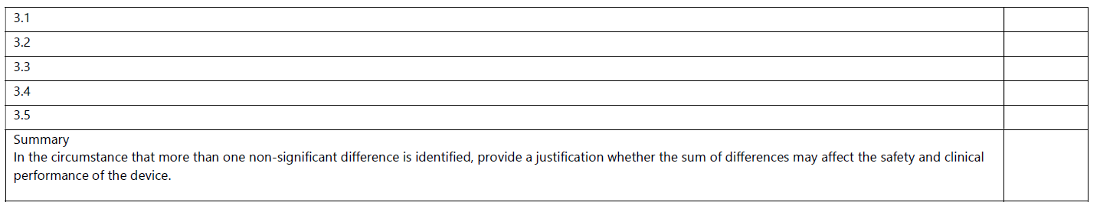

**Justification of equivalence**：{等同理由的说明}

**description of relevant clinical, biological and technical characteristics of the device**：

{对比较的器械的相关临床、生物和技术特征进行描述}

**differences between the intended purpose of the device under evaluation and the equivalent device:**

{说明申报器械与等同器械的预期用途的差异}

**4.2.3 Identification and evaluation of pre-clinical studies carried out and literature used**

{对临床前研究和使用的文献的识别和评价}

**4.2.4 Comparative tabulations for the device under evaluation versus the equivalent device**

{申报器械与对比器械的对比表}

**4.2.5 Identification of differences between device under evaluation and equivalent device**

**4.2.5.1 The difference between device under evaluation and equivalent devices**

**a) Clinical Characteristic Difference**

**b) Technical Characteristic Difference**

**c) Biological Characteristic Difference**

{申报器械与对比器械的不同的比较，包含临床特征的不同、技术特征的不同，以及生物特征的不同}

**4.2.6 Conclusions concerning equivalence**

{关于等同的结论}

*（参考示例:*

*According to the comparison table, the comparison carried out covers all models/ specifications and the entire intended purpose of the device under evaluation. So the conclusion of the equivalence can cover all models and entire intended purpose of the device under evaluation.)*

**4.2.7 Conclusions whether equivalence is demonstrated or not**

{是否可以证明等同的结论}

*（参考示例:*

*Based on the upon comparison and difference analysis of clinical, technical, biological characteristics between device under evaluation and equivalent device, it can be confirmation that the differences are not expected to affect the clinical performance and clinical safety of the device under evaluation. So the equivalence is demonstrated.)*

**4.3. Clinical data generated and held by the manufacturer**

**4.3.1 All pre market clinical investigations**

{所有的上市前临床试验}

***【本处需要描述所有上市前临床试验，如果没有上市前临床试验相关数据，需要说明理由】***

**4.3.2 Clinical data generated from risk management activities and PMS programmes**

{由风险管理活动和PMS计划产生的临床数据}

***【本处需要描述风险管理活动和PMS计划产生的临床数据，包括但不限于 以下来源的临床数据，如 PMS reports, including vigilance reports and trend reports, the literature search and evaluation reports for PMS, incident reports sent to the manufacturer, complaints regarding performance and safety sent to the manufacturer, details of all field safety corrective actions, other user reports.】***

**4.3.2.1 PMCF studies**

{PMCF研究}

***【本处描述上市后临床跟踪研究的内容，或引用相关的PMCF研究方案或报告，如果PMCF研究不适用或不包含在本临床评价报告中的话，需要说明豁免PMCF研究的理由】***

**4.3.2.2 PMS reports, including vigilance reports and trend reports**

{PMS报告，包括警戒报告和趋势报告}

**4.3.2.3 The literature search and evaluation reports for PMS**

{针对PMS的文献搜索和评估报告}

**4.3.2.4 Incident reports sent to the manufacturer**

{制造商收到的事故报告}

**4.3.2.5 Complaints regarding performance and safety sent to the manufacturer**

{制造商收到关于性能和安全的抱怨}

**4.3.2.6 analysis of explanted devices**

{植入器械的分析}

**4.3.2.7 details of all field safety corrective actions**

{所有现场安全纠正措施的相关信息}

**4.3.2.8 use as a custom made device**

{定制式器械的分析}

**4.3.2.9 use under compassionate use/ humanitarian exemption programs**

{在同情使用/人道主义豁免情况下使用}

**4.3.2.10 other user reports**

{其他的用户报告}

**4.3.3 Relevant pre-clinical studies**

{列出申报产品所有上市前的研究}

**4.4.** **Clinical data from literature**

{描述来自文献的临床数据}

*（参考示例:*

*Literature searching is used to identify data not held by the manufacturer that are needed for the clinical evaluation.*

*Literature searching identifies potential sources of clinical data for establishing:*

* *Clinical data relevant to the device under evaluation, which are data that relate either to the device under evaluation or to the equivalent device (if equivalence is claimed).*
* *Current knowledge/ the state of the art.*

*The following aspects were considered for literature searching:*

* *The searching strategy is thorough and objective, which can identify all relevant favorable and unfavorable data. We conduct comprehensive search so that clinical data generated through literature searching can represent the greater part (if not all) of the clinical evidence.*
* *We choose several searches with different search criteria to obtain the necessary data, and adopt several sources of literature.*
* *A literature search and other retrieval of data are carried out based on a search protocol. The search protocol documents the planning of the search before execution.*
* *Once the searches have been executed, compile a literature search report present details of the execution, any deviations from the literature search protocol, and the results of the search.*
* *literature search is documented to such degree that the methods can be appraised critically, the results can be verified, and the search reproduced*

*Based on the upon consideration, we develop the literature protocol which include search strategy and conduct clinical data search, Brief summary and justification of the literature search strategy applied for retrieval of clinical data is following:* {以下需要简要描述文献搜索方案以及搜索结果等方面的内容}*）*

**4.5. Summary and appraisal of clinical data**

**4.5.1 Summary of the clinical data**

**1) Data generated and held by the manufacturer (including clinical experience data)**

{描述来自生产商的数据，包括临床经验数据}

**2) pre market clinical investigations data**

{描述来自上市前的临床试验数据}

**3) Clinical literature data**

**Literature list for included analysis:**

{纳入分析的文献清单}

*（参考表格示例:*

| **No** | **Literature name** | **Resource** | **Author** | **Journal name** | **Published time** | **the introduction of author** |
| --- | --- | --- | --- | --- | --- | --- |
| {文献编号，比如L1} | {文献名称} | {文献来源，比如数据库名称} | {文献作者} | {文献发表的期刊名称} | {文献发表的时间} | {文献作者介绍} |

*）*

**4.5.2. The appraisal plan**

{临床数据的分析方案}

**4.5.3 Conduct of the appraisal**

{开展临床数据的分析}

***【以下仅为临床数据分析的参考，不同的产品以及文献情况的不同，相关的分析方法及内容会不同】***

**4.5.3.1 Evaluation of Data Contribution Rate and Suitability**

*（参考示例：*

***Tabulation of the clinical data and Evaluation of Data Contribution Rate and Suitability***

|  |  |  |  |  |  |
| --- | --- | --- | --- | --- | --- |
| ***No.*** | ***Categories according to Intended Evaluation*** | ***Citable Data*** | ***Suitability Description*** | ***Suitability Appraisal*** | ***Data Contribution Appraisal*** |
| ***Data generated and held by the manufacturer (including clinical experience data)*** | | | | | |
| *1* | *{临床前的测试名称}（参考示例：Performance Test）* | *{临床前测试所满足的标准以及对应的报告}（参考示例：EN166:2001 test report number：***）* | *{对数据的适用性进行描述}（参考示例：The data is from intended evaluating device）* | */* | */* |
| *\*\*\** | *\*\*\*\** | *\*\*\*\** | *\*\*\*\** | */* | */* |
| ***Clinical literature data*** | | | | | |
| *{文献编号}* | *{填写文献数据涉及到产品的哪一方面} 【可以是产品的性能、安全、临床应用的一种或多种】（参考示例：Evaluation of safety performance and clinical application）* | *{填文献名称}* | *{判断数据是来源是申报产品、等同、还是相似产品} （参考示例：The data is from similar device）* | *{对文献质量打分}*  *（参考示例：D3*  *A1*  *P1*  *R1）* | *{对数据贡献进行打分} （参考示例：T1 01 F1 S1 C1）* |
| *{文献编号}* | *{填写文献数据涉及到产品的哪一方面} 【可以是产品的性能、安全、临床应用的一种或多种】（参考示例：Evaluation of safety performance and clinical application）* | *{填文献名称}* | *{判断数据是来源是申报产品、等同、还是相似产品} （参考示例：The data is from similar device）* | *{对文献质量打分}*  *（参考示例：D3*  *A1*  *P1*  *R1）* | *{对数据贡献进行打分} （参考示例：T1 01 F1 S1 C1）* |
| *\*\*\*\** | *\*\*\*\** | *\*\*\*\*\** | *\*\*\*\** | *\*\*\** | *\*\*\** |
| *\*\*\*\** | *\*\*\*\** | *\*\*\*\*\** | *\*\*\*\** | *\*\*\** | *\*\*\** |

*）*

**4.5.3.2 Clinical data analysis from clinical literature**

*（参考示例：*

*The clinical literature included for analysis is total **{文献数量} , the literatures about equivalent devices is **{文献数量} articles, the literatures about similar devices is **{文献数量} articles, which had the same indications, technology principle and the same function structures.*

|  |  |  |  |  |  |
| --- | --- | --- | --- | --- | --- |
| *Device* | *actual device* | *equivalent device* | | | *Other* |
| *1* | *2* | *N* |
| *Literature No.* | *\*\*{文献编号}* | *\*\*{文献编号}* | *\*\*{文献编号}* | *\*\*{文献编号}* | *\*\*{文献编号}* |
| *Total* | *\*\*{文献数量}* | *\*\*{文献数量}* | *\*\*{文献数量}* | *\*\*{文献数量}* | *\*\*{文献数量}* |

*)*

**4.5.3.2.1 Safety, perfomance and clinical application analyasis for the Data set**

{数据集的安全性、性能和临床应用分析}

*（参考示例：*

|  |  |  |
| --- | --- | --- |
| *Data set* | *Literature No.* | *Summary* |
| *safety* | *\*\*{文献编号}* | *{对纳入安全数据集的文献进行总结概要的分析}* |
| *performance* | *\*\*{文献编号}* | *{对纳入性能数据集的文献进行总结概要的分析}* |
| *Clinical application* | *\*\*{文献编号}* | *{对纳入临床应用数据集的文献进行总结概要的分析}* |

*)*

**4.5.3.2.1 Intended use and population analysis for the Data set**

{数据集的预期用途和人群的分析}

*（参考示例：*

| **Literature No** | **Information related to intended clinical application** | **Subjects(cases)** | **patient group** |
| --- | --- | --- | --- |
| *\*\*{文献编号}* | *{对纳入文献进行预期用途和临床应用的分析}* | *{对纳入文献进行受试者的分析}* | *{对纳入文献进行病人组的分析，比如性别、年龄、成人老人等}* |

*)*

**Analysis:** {针对纳入的数据集进行详细的分析，说明对于申报产品的Intended use 及 population 安全及覆盖性的说明，以及与等同器械的等同等}

**4.5.3.2.2 Main endipoint analysis for the Data set**

{数据集的主要研究终点的分析}

*（参考示例：*

| *Literature No* | *Actual or equivalent or similar device* | *Information about Actual or equivalent from Literature* | | | *Endpoint* | *Conclusion* |
| --- | --- | --- | --- | --- | --- | --- |
| *Company name* | *Product name* | *Product model* |
| *\*\*{文献编号}* | *{判断纳入的文献是关于申报器械、等同器械或其他器械}* | *{判断纳入的文献中涉及到申报器械或等同器械的公司名称，如可以，需要说明具体所在的位置页码}* | *{判断纳入的文献涉及到申报器械或等同器械的产品名称，如可以，需要说明具体所在的位置页码}}* | *{判断纳入的文献涉及到申报器械或等同器械的产品型号，如可以，需要说明具体所在的位置页码}* | *{对纳入的文献中研究的相关终点的概要分析}* | *{对纳入的文献中研究的相关终点的概要分总结}* |

**4.5.3.3 Clinical data analysis from Clinical experience**

{对来自临床经验的临床数据分析}

***【需要对收集到的临床经验数据进行分析，包括申报器械、对比器械、相似器械等，如sales data, adverse event, customer complaints, vigilance reports， trend reports ，field safety corrective actions，user reports，以及收集来自各监管机构的公布的不良事件及召回等信息，需要对这些信息进行分析，确保对于适用于申报产品的情况纳入风险分析并采取控制措施尽量减低风险到可接受】***

*（参考示例：以下为监管机构的公布的不良事件及召回等信息汇总的参考表格*

*The Database search Summary form of Clinical data about experience data is following:*

| *Source* | *Sources of data* | *Search query* | *Search time frame* | *Search date* | *Number of search results* | *Number of experience data of actual device* | *Number of experience data of equivalent device* |
| --- | --- | --- | --- | --- | --- | --- | --- |
| *{临床经验数据库的收集来源，比如adverse event and recall report databases}* | *{临床经验数据的收集来源，比如NMPA website}* | *{临床经验数据的搜索词，比如公司名称等}* | *{临床经验数据的搜索的时间范围}* | *{临床经验数据的搜索的日期}* | *{临床经验数据的搜索结果，如搜集到多少数量}* | *{临床经验数据的搜索结果中与申报器械相关的数量}* | *{临床经验数据的搜索结果中与对比器械相关的数量}* |

*)*

*（参考示例：以下为监管机构的公布的召回等信息与风险追溯的参考表格*

| *No* | *Recall reason* | *If it is actual device or equivalent device* | *Is our product has similar risk? (Y/N)* | *Hazards No in RM report*  *Or the justification for NA* |
| --- | --- | --- | --- | --- |
| *{编号}* | *{收集到的经验数据的相关召回原因}* | *{收集到的召回是否申报产品或对比产品}* | *{申报产品是否有类似的风险}* | *{如果申报产品有类似的风险，对应的风险管理报告中的危害编号；如果申报产品没有类似的风险，需要说明理由}* |

*)*

**4.6. Analysis of the clinical data**

### 4.6.1. Requirement on safety(MDR ER4)

{此处需要说明对于MDR ER4中关于安全要求符合性的相关分析}

**4.6.2. Requirement on acceptable benefit/risk profile (MDR ER2)**

{此处需要说明对于MDR ER2中关于风险受益特征可接受性要求符合性的相关分析}

**4.6.3. Requirement on performance(MDR ER1)**

{此处需要说明对于MDR ER1中关于性能要求符合性的相关分析}

**4.6.4. Requirement on acceptability of side-effects (MDR ER8)**

{此处需要说明对于MDR ER8中关于副作用可接受性要求符合性的相关分析}

1. **Conclusion**

{结论}

*（参考示例：以下提供通用的临床评价报告的结论供参考，需要结合实际产品临床评价的内容进行调整*

*After the clinical evaluation for the device under evaluation, it can proved that:*

* *The device is compliance to Essential requirements;*
* *the benefit/risk profile according to current knowledge/ the state of the art in the medical fields concerned and according to available medical alternatives is acceptable;*
* *the information materials supplied by the manufacturer is adequate, the intended purpose and risk reduction measures are adequate, no discrepancies;*
* *the device, including its IFU, for the intended users and usability aspects, is suitable, no discrepancies;*
* *claims foreseen by the manufacturer is adequate, no discrepancies;*
* *it is consistent between the clinical data, the information materials supplied by the manufacturer, the risk management documentation for the device under evaluation, no discrepancies;*
* *it is consistent between these documents and the current knowledge/ the state of the art, no discrepancies;*
* *residual risks are acceptable for CE-marking, and how the residual risk followed during PMS are already being addressed in ongoing PMS activities;*
* *new or additional PMS activities can be foreseen.*

*The clinical evaluation report is written according to the suggested format for the clinical evaluation report, which located at Appendix A9 (Clinical evaluation report - proposed table of contents, examples of contents) of MEDDEV 2.7.1 rev.4*

*And also check the aspects for the release of a clinical evaluation report summarised in Appendix A10 (Proposed checklist for the release of the clinical evaluation report) of MEDDEV 2.7.1 rev.4.*

*The detail can be referred to Annex 5 Clinical evaluation checklist.)*

**6. Date of the next clinical evaluation**

**6.1 Suggested date**

{填写下次临床评价报告更新的建议日期}

*（参考示例：*

*The clinical evaluation is actively updated:*

* *when the manufacturer receives new information from PMS that has the potential to change the current evaluation;*
* *if no such information is received, then every 2 to 5 years,* *because the device is not expected to carry significant risks and is well established.*

*In additional, the device under evaluation is required involvement of notified bodies, updates are usually coordinated with the notified body. Typically, they are aligned with the timetable for surveillance audits and the renewal of the certificates.)*

**6.2** **Justification of the date**

{填写建议临床评价日期的理由 }

*（参考示例：*

*The manufacturer defines and justifies the frequency(in section 6.1) at which the clinical evaluation needs to be actively updated, the main justification is that the device is not expected to carry significant risks and is well established.The detailed justification is following:*

* *The device negligibly carries significant risks because the design, materials, components,clinical procedures of the device under evaluation are very common in many similar nature dressing products in the market, which are clinical used for several years, eg: equivalent devices.*
* *the device under evaluation is well established because:*

*1) the device under evaluation is not innovation;*

*2) and there are no relevant changes in clinical sciences, materials sciences or other sciences related to the device under evaluation;*

*3) In additional, the current level of confidence in the evaluation of clinical performance and clinical safety of the device is high enough, because the data available from pre-clinical study on the device under evaluation had proved that the device well conform to the relevant specifications, the data available from clinical literatures, PMS, registries or other systematic studies related to the equivalent devices and similar devices had proved that the device is safety and effectiveness and no risk residual after risk analysis and controlled which identify from these clinical experiences data. Moreover, equivalent device is been used in the market for many years and is very widely used and there is no relevant adverse events and recalls reported related to the equivalent device after searching the database.*

* *After the risk analysis, so far there are no risks and uncertainties or unanswered questions, in the medium or long term, that would influence the frequency of updates.*
* *In the change plan, there is no design changes or changes to manufacturing procedures related to the device under evaluation.**)*

**7. Dates and signatures**

**7.1 The clinical evaluation team**

{填写临床评价的团队及分工 }

*（参考示例：*

|  |  |  |  |  |  |
| --- | --- | --- | --- | --- | --- |
| *Members* | *Major* | *Degree* | *Depart* | *Position* | *Responsibility* |
| *{填写参与临床评价报告的人员名称}* | *{填写参与临床评价报告的人员专业背景} （参考示例：Electrical engineering and automation）* | *{填写参与临床评价报告的人员学历} （参考示例：Bachelor）* | *{填写参与临床评价报告的人员所属部门} （参考示例：RA Department）* | *{填写参与临床评价报告的人员职位} （参考示例：Clinical expert，Team Leader）* | *{填写参与临床评价报告的人员职责}（参考示例：Connect customer requirement and feedback marketing information, Collect after-sales service information）* |

*)*

**7.2 Date and signatures of the evaluators**

{填写临床评价的团队人员签字 }

*（参考示例：*

|  |  |  |  |  |  |  |
| --- | --- | --- | --- | --- | --- | --- |
| *Members* | *Major* | *Degree* | *Depart* | *Position* | *Signature* | *Date* |
| *{填写参与临床评价报告的人员名称}* | *{填写参与临床评价报告的人员专业背景} （参考示例：Electrical engineering and automation）* | *{填写参与临床评价报告的人员学历} （参考示例：Bachelor）* | *{填写参与临床评价报告的人员所属部门} （参考示例：RA Department）* | *{填写参与临床评价报告的人员职位} （参考示例：Clinical expert，Team Leader）* | *{填写参与临床评价报告的人员签字}* | *{签日期}* |

*)*

1. **Qualification of the responsible evaluators**

{请填入临床评价人员的资质证明}

***【临床评价需要由适当资质的团队开展，需要考虑如下的方面，且为说明符合资质条件需要提供相关的证明文件或说明，如简历等***

1. *the evaluators that are in line with the nature of the device under evaluation and its clinical performance and risks;*
2. *the evaluators are chosen through reference to their qualifications and documented experience, and to present a declaration of interest for each evaluator;*
3. *the evaluators possess knowledge, eg: research methodology, information management, regulatory requirements, regulatory requirements, ect;*
4. *With respect to the device under evaluation, the evaluators in addition have knowledge, eg: the device technology and its application; diagnosis and management of the conditions intended to be diagnosed or managed by the device, knowledge of medical alternatives, treatment standards and technology;*
5. *The evaluators have training and experience in the relevant field proved by the degree from higher education in the respective field combined with professional experience.*

*There is not circumstances where the level of evaluator expertise may be less or different above.】*

1. **References**

{列出临床评价报告所参考的法规、指南及引用的文献等}

*（参考示例：MEDDEV 2.7/1 revision 4 CLINICAL EVALUATION: A GUIDE FOR MANUFACTURERS AND NOTIFIED BODIES UNDER DIRECTIVES 93/42/EEC and 90/385/EEC*

*REGULATION (EU) 2017/745 OF THE EUROPEAN PARLIAMENT AND OF THE COUNCIL*

*of 5 April 2017 on medical devices, amending Directive 2001/83/EC, Regulation (EC) No 178/2002 and Regulation (EC) No 1223/2009 and repealing Council Directives 90/385/EEC and 93/42/EEC）*

1. **Annex**

{列出临床评价报告的相关附录}

*（参考示例：*

*10.1 Annex 1- CV of evaluators*

*10.2 Annex 2- Literature Search Protocol and Report*

*10.3* *Annex 3-CV of searcher*

*10.4 Annex 4-The literatures used for analysis*

*10.5 Annex 6-Declaration of Interests*

*10.6 Annex 7-CE Certificate of Equivalent devices*

*10.7 Annex 8-Clinical Evaluation Plan*

*10.8 Annex 8-Clinical investigation report）*