**Literature search report**

**Product Name:** **{产品名称}**

***【本处填写产品名称，需要确保全篇技术文档及报告等的名称一致】***

**Model:** **{产品型号1}、{产品型号2}、{产品型号N}**

***【需要罗列本次认证的所有产品型号清单，如型号很多，可以采用另外附件文档的方式给出】***

**Document No.:** **{文件编号}**

***【本处填写本文件的编号】***

**Edition: {文件版本}**

***【本处填写本文件的版本】***

Drafted by : {XX名字} Date： {年-月-日}

Checked by: {XX名字} Date： {年-月-日}

Approved by: {XX名字} Date： {年-月-日}

***【以上分别由负责本文档的编写、审核、批准的人员进行签字和日期，需要注意文件的签署人员和日期等信息与相关体系文档的符合性及逻辑性】***

{XXXX公司}

**Revision records:**

|  |  |  |  |  |  |
| --- | --- | --- | --- | --- | --- |
| **Edition** | **Effective Date** | **Summary of revision** | **Drafted by** | **Checked by** | **Approved by** |
| {文件版本1} | {年-月-日} | First release | {XX名字} | {XX名字} | {XX名字} |
| {文件版本2} | {年-月-日} | {本版本相对上一版本版本更新了****，主要原因是****, 涉及到修改的小节是*****}  *【填写本技术文档的版本相对于上一版本更新了哪些内容？为什么更新？以及更新内容具体的地方及小节编号？】* | {XX名字} | {XX名字} | {XX名字} |
| {文件版本N} | {年-月-日} | {本版本相对上一版本版本更新了****，主要原因是****, 涉及到修改的小节是*****}  *【填写本技术文档的版本相对于上一版本更新了哪些内容？为什么更新？以及更新内容具体的地方及小节编号？】* | {XX名字} | {XX名字} | {XX名字} |
|  |  |  |  |  |  |
|  |  |  |  |  |  |
|  |  |  |  |  |  |
|  |  |  |  |  |  |
|  |  |  |  |  |  |
|  |  |  |  |  |  |
|  |  |  |  |  |  |
|  |  |  |  |  |  |
|  |  |  |  |  |  |

**Table of Contents**

1.Background to the literature search and the literature review 4

1.1 Device name/model 5

1.2 Importance of literature review to risk management process 5

1.3 Previous literature reviews 5

1.4 Importance of review to risk management process 5

1.5 Previous literature searches conducted by the manufacturer 6

1.6 If including equivalent or benchmark devices, name and model of the devices 6

1.7 The CER will need to establish equivalence to the device under evaluation or the relevance of benchmark devices to the clinical evaluation 7

2. Objective 7

3. Scope of the literature search 8

4. Methods 8

4.1 Date of search 8

4.2 Name of person(s) undertaking the literature search and literature search methodology 8

4.3 Period covered by search 8

4.4 The sources of data that will be used and a justification for their choice 9

scientific databases – bibliographic 9

4.5 Database search details 10

4.5.1 Search terms and their relationships and justification for search strategy--for clinical literature data 10

4.5.2 Search terms and their relationships and justification for search strategy--for clinical experience data 10

4.5.3 Medium used 11

4.6 Selection/ exclusion criteria used to choose articles and justification for the choice 11

4.6.1 For clinical literature data 11

4.6.2 For clinical experience data 11

4.7 Any deviations from the literature search protocol 12

5. Output 12

5.1 Clinical data about Literature data 12

5.1.1 Database search details 12

5.1.2 Attach copy of literature citations retrieved from each database search 13

5.1.3 Data selection process 13

5.2 Clinical data about experience data 14

5.2.1 Database search details 14

5.2.2 experience data citations retrieved from each database search 15

5.2.3 Data selection process 16

Annex I : Data evaluation criteria 18

Annex III The data summary table of experience data searched from ***{数据库} 21

**1.Background to the literature search and the literature review**

This section documents the importance of and rationale for the literature review:

* 1. **Device name/model**

Product Name: **{产品名称}**

Model: **{产品型号1}、{产品型号2}、{产品型号N}**

***【需要罗列本次认证的所有产品型号清单，如型号很多，可以采用另外附件文档的方式给出】***

* 1. **Importance of literature review to risk management process**

**{**文献评估对风险管理过程的重要性**}**

*（参考示例:*

*The literature review will provide data on current interventions for the intended patient population (state of the art) in order to give input to the assessments of acceptable benefit/risk profiles, what is currently considered as providing a high level of protection of health and safety and what are considered acceptable side-effects.）*

* 1. **Previous literature reviews**

{描述之前的文献评估}

* 1. **Importance of review to risk management process**

{审查对风险管理过程的重要性}

*（参考示例:*

*1)Risk/benefit analysis*

*If the residual risk is not judged acceptable using the criteria established in the risk management plan and further risk control is not practicable, the manufacturer may gather and review data and literature to determine if the medical benefits of the intended use outweigh the residual risk*

1. *Evaluation of overall residual risk acceptability*

*If the overall residual risk is not judged acceptable using the criteria established in the risk management plan, the manufacturer may gather and review data and literature to determine if the medical benefits of the intended use outweigh the overall residual risk;*

1. *Risk/benefit comparison*

*Direct comparison of risks and benefits is only valid if a common scale is used. When a common scale is used, the risk to benefit comparison can be evaluated quantitatively. Indirect risk/benefit comparisons do not use a common scale and are evaluated qualitatively. Whether quantitative or qualitative, risk/benefit comparisons can be Initially considered that a literature search for the hazard(s) and product class in question can provide significant insight into the ratio of benefit to risk.*

1. *Production and post-production monitoring）*
   1. **Previous literature searches conducted by the manufacturer**

{描述生产商之前的文献搜索}

* 1. **If including equivalent or benchmark devices, name and model of the devices**

{描述是否包括等同或基准设备，设备的名称和型号}

*（参考示例:*

|  |  |
| --- | --- |
| **Equivalent device 1** | Name: {等同器械名称}  Models: {等同器械型号}  Sizes: {等同器械尺寸}  components:{等同器械构成}  Software:{等同器械软件}  Accessories: {等同器械附件} |
| **Manufacturer** | {等同器械生产商} |
| **NB number** | {等同器械发证的CE公告机构编号} |
| **CE Certificate No.** | {等同器械的CE证书编号} |

|  |  |
| --- | --- |
| **Equivalent device N** | Name: {等同器械名称}  Models: {等同器械型号}  Sizes: {等同器械尺寸}  components:{等同器械构成}  Software:{等同器械软件}  Accessories: {等同器械附件} |
| **Manufacturer** | {等同器械生产商} |
| **NB number** | {等同器械发证的CE公告机构编号} |
| **CE Certificate No.** | {等同器械的CE证书编号} |

*）*

**1.7 The CER will need to establish equivalence to the device under evaluation or the relevance of benchmark devices to the clinical evaluation**

*The CER had establish equivalence to the device under evaluation, which can be referred to Clinical Evaluation Report.*

1. **Objective**

*（参考示例:*

*This section documents the research question(s), which is consistent with the scope of the clinical evaluation and carefully constructed using a process. The literature search and review is focused on the Population(s)/disease(s) or condition(s), Intervention(s), Comparator group(s)/control(s), Outcome(s)/endpoint(s). And the inputs for the review question(s) are the device description and the intended performance of the device including any claims on clinical performance and clinical safety which the manufacturer wants to use. Also information from the risk management process is needed as an input.*

*Objective of the literature review is following:*

*To demonstrate the actual device has achieving its intended use and performance during normal conditions of use and that the known and foreseeable risks, and any adverse events are minimised and acceptable when weighed against the benefits of the intended performance, and that any claims made about the device’s performance and safety are supported by suitable evidence.)*

1. **Scope of the literature search**

*（参考示例:*

*1) Intended purpose and application of the device;*

*2) Manufacturer’s specific claims about clinical performance and safety of device;*

*3) The significance of any risks that remain;*

*4) The data source and type of data to be used in the clinical evaluation.*

*5) Products/ models/ sizes/ settings and the technology on which the medical device is based)*

1. **Methods**

*（参考示例:*

*The methods section of the protocol documents the plans for literature search, study selection, data collection, and analysis methods. It defines the literature search strategy and the inclusion/exclusion criteria for the documents found.*

*The literature search report is following: )*

* 1. **Date of search**

Please referred to section 5.1.2 and 5.2.2.

* 1. **Name of person(s) undertaking the literature search and literature search methodology**

The literature search protocol is developed and executed by persons with expertise in information retrieval, having due regard to the scope of the clinical evaluation set out by the manufacturer. The searcher should help to optimize literature retrieval to identify all relevant published literature.

The importance of a literature search protocol is for critical appraisal of the methods. The search strategy should be based on carefully constructed review questions.

The report should be include the the persons information who conduct searcher and the personal CV.

The CV of searcher can be refer to Annex 3-CV of searcher in Clinical Evaluation Report.

* 1. **Period covered by search**

For comprehensive searching clinical data, the period covered by search is at least the relevant {填写搜索覆盖的年限} years, and should consider the development history of the technology involved in the actual device.

Period: please refer to section 5.1.2 and 5.2.2

**4.4 The sources of data that will be used and a justification for their choice**

There are different sources of clinical literature that can be searched for clinical evaluation. For a comprehensive search , involving multiple databases. The search strategy should be documented and justified. Clinical literature Data searched is all taken from recognized scientific publications, in order to avoid publication bias, there are no Unpublished data.The sources of data that will be used and the justification for choice of sources are described below:

{填写选择搜索的数据库来源，以及选择的依据}

***【对于每一个选择的数据库，至少包需要提供信息，比如Sources of data、Extent of the searches、Justification for choice of sources 等】***

（参考示例:

**scientific databases – bibliographic**

**Sources of data**: MEDLINE Pubmed, CNKI, Science direct, Cochrane Library

**Extent of the searches**: Comprehensive

**Justification for** **choice of sources**: The MEDLINE Pubmed , CNKI and Science direct and Cochrane Library have plentiful documents for the general information about the clinical data. Science Direct and MEDLINE Pubmed are both high quality academic journal database. The [Cochrane Library](http://www.cochranelibrary.com/" \o "[Opens in new window] http://www.cochranelibrary.com/" \t "https://www.cochrane.org/about-us/_blank) is an online collection of six databases that contain different types of high-quality, independent evidence to inform healthcare decision-making, and a seventh database that provides information about Cochrane Groups. And CNKI is a large scale integration of information resources, so the rich contents and high quality resources is enough for our clinical evaluation. And the documents in MEDLINE Pubmed ,CNKI ,Science direct and Cochrane Library are enough for our clinical evaluation.)

## 4.5 Database search details

### 4.5.1 Search terms and their relationships and justification for search strategy--for clinical literature data

**1) Search terms and and their relationships**

{搜索词及其关系}

（参考示例:

| **Item** | **Keyword for international database** | **Keyword for Chinese database** |
| --- | --- | --- |
| {搜索词的类别}  *（参考示例:Keyword involved main function and Characteristics，keyword about manufacturer name of equivalent device)* | {国际数据库用到的搜索词} | {中国数据库用到的搜索词} |

)

1. **search strategy and justification for search strategy**

{搜索策略和搜索策略的理由}

**4.5.2 Search terms and their relationships and justification for search strategy--for clinical experience data**

1. **Search terms and and their relationships**

{搜索词及其关系}

（参考示例:

| **database** | **Keyword** | **justification for search strategy** |
| --- | --- | --- |
| {数据库名称}  *（参考示例:NMPA website，FDA website)* | {搜索词} | {搜索策略的理由} |

)

**2) search strategy and justification for search strategy**

Refer to the above table.

### 4.5.3 Medium used

All the data are searching online, and the search way as follow：

|  |  |  |  |
| --- | --- | --- | --- |
| **Data type** | **Source** | **Sources of data** | **access way** |
| {数据类型}*（参考示例:clinical literature data，clinical experience data)* | {数据来源}*（参考示例:adverse event and recall report databases)* | {数据源}*（参考示例:CNKI)* | {数据库路径}*（参考示例:<http://epub.cnki.net/kns/default.aspx>)* |

## 4.6 Selection/ exclusion criteria used to choose articles and justification for the choice

**4.6.1 For clinical literature data**

**Screening Processing:**

{简要描述数据筛选过程}

**The** **selection/exclusion criteria used for the screening literature is mainly following:**

**Include** **criteria:**

{描述数据入选准则}

**exclusion criteria:**

{描述数据排除准则}

**The justification for selection/exclusion criteria:**

{描述数据入选及排除准则的理由}

**4.6.2 For clinical experience data**

**Screening Processing:**

{简要描述数据筛选过程}

**The selection/exclusion criteria used for the screening experience data is mainly following:**

**Include criteria:**

{描述数据入选准则}

**exclusion criteria:**

{描述数据排除准则}

**The justification for selection/exclusion criteria:**

{描述数据入选及排除准则的理由}

Based on the above justification, we set the selection/exclusion criteria.

**4.7 Any deviations from the literature search protocol**

{与文献搜索方案之间的任何偏差}

1. **Output**
   1. **Clinical data about Literature data**

### Database search details

{数据库搜索细节}

***【此处放搜索过程中的搜索截图、以及所用的数据库、关键词、搜索结果等信息】***

（参考示例:

#### *MEDLINE Pubmed*

*Using the* *advanced search of MEDLINE Pubmed, the results are following:*

*Title/Abstract：acupuncture therapy 1055*

***CNKI***

*Using the advanced search of CNKI, the results are following:*

*Abstract(摘要)：针灸疗法 6126*

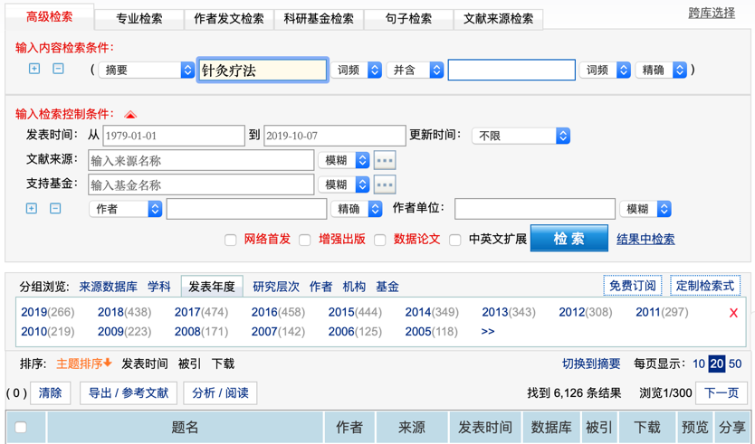

)

* + 1. **Attach copy of literature citations retrieved from each database search**

The Database search summary form of Clinical data about Literature data is following:

|  |  |  |  |  |  |  |
| --- | --- | --- | --- | --- | --- | --- |
| **Source** | **Sources of data** | **Search query** | **Search time frame** | **Search date** | **Number of search results** | **Number of search results included into data selection** |
| *{临床文献数据库的收集来源，比如clinical trial registers，scientific databases – bibliographic}* | *{临床文献数据的收集来源，比如Pubmed}* | *{临床文献数据的搜索词，比如公司名称等}* | *{临床文献数据的搜索的时间范围}* | *{临床文献数据的搜索的日期}* | *{临床文献数据的搜索结果，如搜集到多少数量}* | *{临床文献数据纳入分析的数量}* |

**5.1.3 Data selection process**

**5.1.3.1 Flow chart**

{数据选择过程的流程图}

***【此处放数据选择过程的流程图】***

（参考示例:

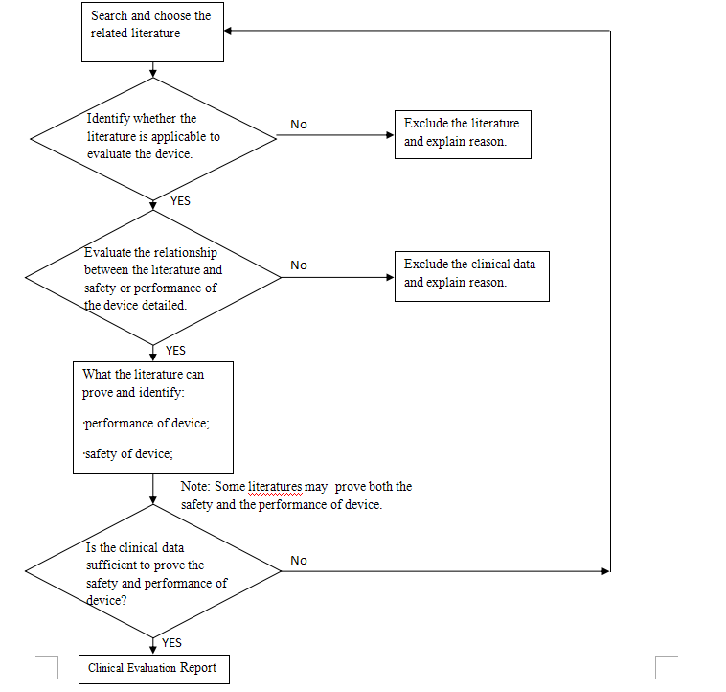)

#### 5.1.3.2 Tables showing how all citations were assessed

{此处需要提供所有纳入的文献数据是如何被评估的表格}

#### 5.1.3.3 Identified literature for the evaluation abstract and analysis

{对纳入的每一篇文献进行摘要评估以及分析}

* 1. **Clinical data about experience data**

### Database search details

{数据库搜索细节}

***【此处放搜索过程中的搜索截图、以及所用的数据库、关键词、搜索结果等信息】***

（参考示例:

*NMPA website*

*Keyword: 针灸针 95*

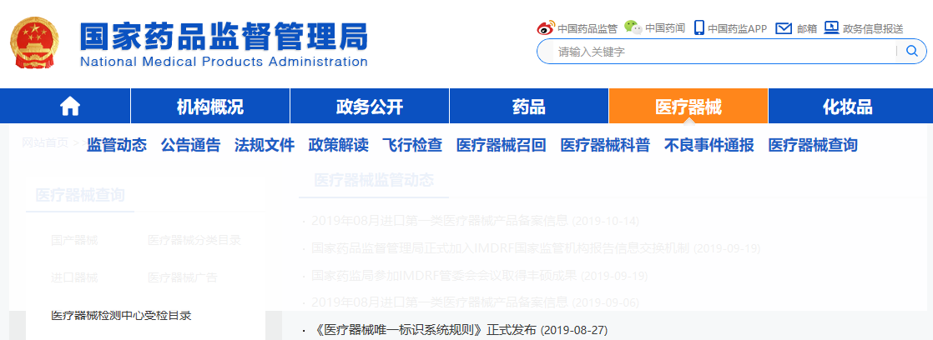

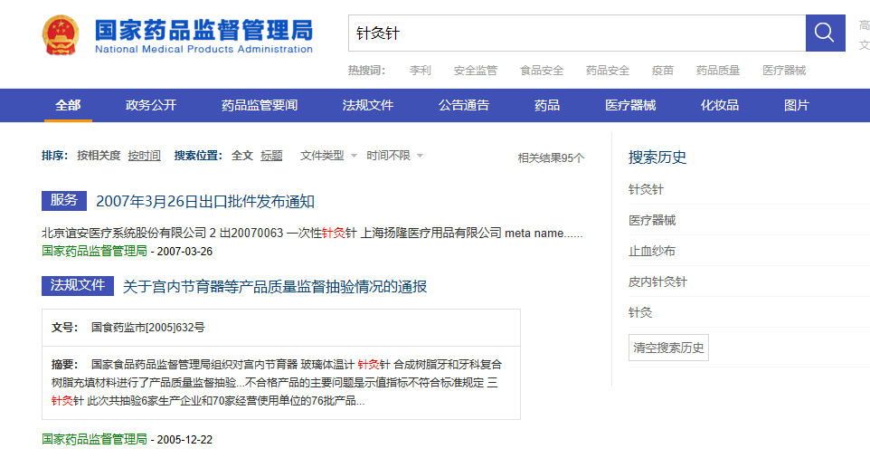

*Summary：*

*Reading and analyzing the all data [item](javascript:void(0);) [by](javascript:void(0);) [item](javascript:void(0);), There were no data occurred in the database for actual device and the equivalent device.）*

* + 1. **experience data citations retrieved from each database search**

The Database search Summary form of Clinical data about experience data is following:

| *Source* | *Sources of data* | *Search query* | *Search time frame* | *Search date* | *Number of search results* | *Number of experience data of actual device* | *Number of experience data of equivalent device* |
| --- | --- | --- | --- | --- | --- | --- | --- |
| *{临床经验数据库的收集来源，比如adverse event and recall report databases}* | *{临床经验数据的收集来源，比如NMPA website}* | *{临床经验数据的搜索词，比如公司名称等}* | *{临床经验数据的搜索的时间范围}* | *{临床经验数据的搜索的日期}* | *{临床经验数据的搜索结果，如搜集到多少数量}* | *{临床经验数据的搜索结果中与申报器械相关的数量}* | *{临床经验数据的搜索结果中与对比器械相关的数量}* |

### 5.2.3 Data selection process

#### 5.2.3.1 Flow chart

{数据选择过程的流程图}

***【此处放数据选择过程的流程图】***

（参考示例:

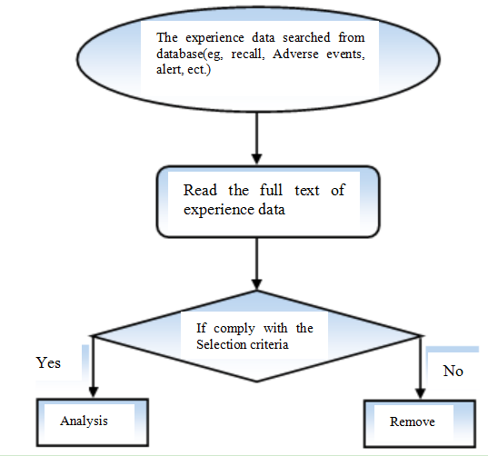)

#### 5.2.3.2 Tables showing how all citations were assessed

{此处需要提供所有纳入的文献数据是如何被评估的表格}

#### 5.2.3.3 Risk analysis and control trace to experience data

{与经验数据追溯的风险分析和控制}

**Annex** I **: Data evaluation criteria**

{数据评估的准则}

***【本处为对收集的文献及临床数据等的分析评价标准，需要结合实际情况制定】***

*（参考示例:*

*Table 1: Appraisal Criteria for Suitability*

| ***Suitability Criteria*** | ***Description*** | ***Grading System*** |
| --- | --- | --- |
| *Appropriate device* | *Were the data generated from the device in question?* | *D1 Actual device*  *D2 Equivalent device*  *D3 Other device* |
| *Appropriate device application* | *Was the device used for the same intended use (e.g., methods of deployment, application, etc.)?* | *A1 Same use*  *A2 Minor deviation*  *A3 Major deviation* |
| *Appropriate patient group* | *Were the data generated from a patient group that is representative of the intended treatment population (e.g., age, sex, etc.) and clinical condition (i.e., disease, including state and severity)?* | *P1 Applicable*  *P2 Limited*  *P3 Different population* |
| *Acceptable report/data collation* | *Do the reports or collations of data contain sufficient information to be able to undertake a rational and objective assessment?* | *R1 High quality*  *R2 Minor deficiencies*  *R3 Insufficient information* |

*Table 2: Appraisal Criteria for Data Contribution*

| ***Data Contribution Criteria*** | ***Description*** | ***Grading System*** |
| --- | --- | --- |
| *Data source type* | *Was the design of the study appropriate?* | *T1 Yes*  *T2 No* |
| *Outcome measures* | *Do the outcome measures reported reflect the intended performance of the device?* | *O1 Yes*  *O2 No* |
| *Follow up* | *Is the duration of follow-up long enough to assess whether duration of treatment effects and identify complications?* | *F1 Yes*  *F2 No* |
| *Statistical significance* | *Has a statistical analysis of the data been provided and is it appropriate?* | *S1 Yes*  *S2 No* |
| *performance the device* | *Do the data address the performance of the device in question?* | *PE1 Yes*  *PE2 No* |
| *safety of the device* | *Do the data address the safety of the device in question?* | *SA1 Yes*  *SA2 No* |
| *Clinical significance* | *Was the magnitude of the treatment effect observed clinically significant?* | *C1 Yes*  *C2 No* |

*)*

**Annex II: Literature list and evaluation result**

{纳入分析的文献清单及评估结果}

*（参考表格示例:*

| **No** | **Literature name** | **Resource** | **Author** | **Journal name** | **Published time** | **the introduction of author** | **Suitability Appraisal** | **Data Contribution Appraisal** |
| --- | --- | --- | --- | --- | --- | --- | --- | --- |
| {文献编号，比如L1} | {文献名称} | {文献来源，比如数据库名称} | {文献作者} | {文献发表的期刊名称} | {文献发表的时间} | {文献作者介绍} | {对文献质量打分}  *（参考示例：D3*  *A1*  *P1*  *R1）* | {对数据贡献进行打分} *（参考示例：T1 01 F1 S1 C1）* |

*）*

**Annex III The data summary table of experience data searched from \*\*\***{数据库}

{搜索自某数据库的经验数据的总结表格}

*（参考示例：以下为监管机构的公布的召回等信息与风险追溯的参考表格*

| *No* | *Recall reason* | *If it is actual device or equivalent device* | *Is our product has similar risk? (Y/N)* | *Hazards No in RM report*  *Or the justification for NA* |
| --- | --- | --- | --- | --- |
| *{编号}* | *{收集到的经验数据的相关召回原因}* | *{收集到的召回是否申报产品或对比产品}* | *{申报产品是否有类似的风险}* | *{如果申报产品有类似的风险，对应的风险管理报告中的危害编号；如果申报产品没有类似的风险，需要说明理由}* |

*)*