**Usability Engineering Process Program**

**Product Name:** ***{产品名称 }***

**Model:** ***{产品型号}***

**Document No.:** ***{文件编号}***

**Edition: *{文件版本}***

Drafted by : {XX名字} Date： {年-月-日}

Checked by: {XX名字} Date： {年-月-日}

Approved by: {XX名字} Date： {年-月-日}

{XXXX公司}

**Revision records:**

|  |  |  |  |  |  |
| --- | --- | --- | --- | --- | --- |
| **Edition** | **Effective Date** | **Summary of revision** | **Drafted by** | **Checked by** | **Approved by** |
| {文件版本1} | {年-月-日} | First release | {XX名字} | {XX名字} | {XX名字} |
| {文件版本2} | {年-月-日} | {本版本相对上一版本版本更新了****，主要原因是****, 涉及到修改的小节是*****}  *【填写本技术文档的版本相对于上一版本更新了哪些内容？为什么更新？以及更新内容具体的地方及小节编号？】* | {XX名字} | {XX名字} | {XX名字} |
| {文件版本N} | {年-月-日} | {本版本相对上一版本版本更新了****，主要原因是****, 涉及到修改的小节是*****}  *【填写本技术文档的版本相对于上一版本更新了哪些内容？为什么更新？以及更新内容具体的地方及小节编号？】* | {XX名字} | {XX名字} | {XX名字} |
|  |  |  |  |  |  |
|  |  |  |  |  |  |
|  |  |  |  |  |  |
|  |  |  |  |  |  |
|  |  |  |  |  |  |
|  |  |  |  |  |  |
|  |  |  |  |  |  |
|  |  |  |  |  |  |
|  |  |  |  |  |  |
|  |  |  |  |  |  |

**Table of Contents**

1 Scope 4

2 Organization 4

3 RISK CONTROL as it relates to USER INTERFACE design 6

4 Information for safety as it relates to USABILITY 6

5 Usability engineering file 8

6 Tailoring of the USABILITY ENGINEERING effort 8

7 Overview of the usability engineering process 8

7.1 Prepare USE SPECIFICATION 11

7.2 Identify USER INTERFACE characteristics related to SAFETY and potential USE ERRORS 12

7.3 Identify known or foreseeable HAZARDS and HAZARDOUS SITUATIONS 12

7.4 Identify and describe HAZARD-RELATED USE SCENARIOS 13

7.5 Select the HAZARD-RELATED USE SCENARIOS for SUMMATIVE EVALUATION 13

7.6 Establish USER INTERFACE SPECIFICATION 13

7.7 Establish USER INTERFACE EVALUATION plan 14

7.7.1 General 14

7.7.2 FORMATIVE EVALUATION planning 15

7.7.3 SUMMATIVE EVALUATION planning 15

7.8 Perform USER INTERFACE design, implementation and FORMATIVE EVALUATION 16

7.9 Perform SUMMATIVE EVALUATION of the USABILITY of the USER INTERFACE 16

7.10 USER INTERFACE OF UNKNOWN PROVENANCE 17

**Usability Engineering Process Program**

# Scope

This usability engineering process procedure is intended to provide safety for the patient, user and others related to usability. This usability engineering process procedure intended to address user interactions with the device, ***{产品名称 }***,according to the accompanying documentation , including, but not limited to:

‐ transport

‐ storage

‐ installation

‐ operation

‐ maintenance and repair；

‐ disposal

USABILITY ENGINEERING activities for a MEDICAL DEVICE shall be planned, carried out, and documented by personnel competent on the base of appropriate education, training, skills or experience.

Where a documented product realization PROCESS exists, such as that described in Clause 7 of ISO 13485, it shall incorporate the appropriate parts of or reference the USABILITY ENGINEERING PROCESS.

This procedure shall be conducted through medical device design and development life-cycle once new issue related to use safety is raised.

# Organization

It is recommended for a MEDICAL DEVICE development team to have available adequate USABILITY ENGINEERING expertise and include at least one USABILITY SPECIALIST, as needed.

The USABILITY SPECIALIST should have relevant, appropriate training (e.g. in USABILITY ENGINEERING) and have appropriate MEDICAL DEVICE domain knowledge. USABILITY ENGINEERING expertise can also be gained through formal USABILITY ENGINEERING education, complemented by applicable experience applying the USABILITY ENGINEERING PROCESS to MEDICAL DEVICE development.

USABILITY ENGINEERING expertise can also be provided by individuals who are self-educated in the field and those who have attended courses intended to teach them important USABILITY ENGINEERING concepts and best practices related to MEDICAL DEVICE development.

Among others, the following types of professionals can also participate actively in USABILITY ENGINEERING activities, such as contributing to the USABILITY ENGINEERING project plan, participating in the analysis of USABILITY problems, designing or modifying a MEDICAL DEVICE’S USER INTERFACE or observing and analysing the results of USABILITY TESTS:

a) technical writers responsible for developing the learning tools associated with a MEDICAL DEVICE; tools such as quick reference cards, USERS manuals, other ACCOMPANYING DOCUMENTATION, online help, and educational posters;

b) training course developers and trainers;

c) marketing specialists who have a strong appreciation for USABILITY ENGINEERING and recognize the important differences between USABILITY ENGINEERING and market research;

d) clinicians who have a strong understanding of the USER perspective;

e) developers who build USER INTERFACE prototypes for use in USABILITY TESTS;

f) engineers and designers who have learned about USABILITY ENGINEERING to enable their own work or manage the USABILITY ENGINEERING efforts of other development team members.

# RISK CONTROL as it relates to USER INTERFACE design

To reduce use-related RISK, the MANUFACTURER shall use one or more of the following options, in the priority listed:

a) inherent SAFETY by design;

b) protective measures in the MEDICAL DEVICE itself or in the manufacturing PROCESS;

c) information for SAFETY.

NOTE Information for SAFETY can also be required by product standards and other sources.

# Information for safety as it relates to USABILITY

When, in accordance with the priorities of 4.1.2 of IEC 62366-2015, information for SAFETY is used as a RISK CONTROL measure, the MANUFACTURER shall subject this information to the USABILITY ENGINEERING PROCESS to determine that the information

– is perceivable by,

– is understandable to, and

– supports CORRECT USE of the MEDICAL DEVICE by USERS of the intended USER PROFILES in the context of the intended USE ENVIRONMENT.

NOTE 1 The relationship between USER perception, cognition and action is shown in Figure A.1 of IEC 62366-2015

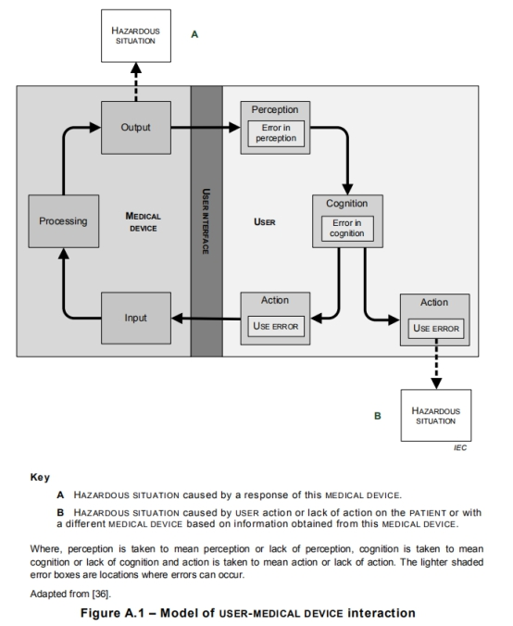

Conscious disregard of such information for SAFETY by the USER is considered to be an intentional act or intentional omission of an act that is counter to or violates NORMAL USE and is also beyond any further reasonable means of USER INTERFACE-related RISK CONTROL by the MANUFACTURER (i.e. ABNORMAL USE).

# Usability engineering file

The results of the usability engineering process shall be recorded in the usability engineering file. The records and other documents that form the usability engineering

file may form part of other documents and files.

# Tailoring of the USABILITY ENGINEERING effort

The level of effort and the choice of methods and tools used to perform the USABILITY ENGINEERING PROCESS may vary based on:

a) the size and COMPLEXITY of the USER INTERFACE;

b) the SEVERITY of the HARM associated with the use of the MEDICAL DEVICE;

c) the extent or complexity of the USE SPECIFICATION;

d) the presence of USER INTERFACE OF UNKNOWN PROVENANCE; and

e) the extent of the modification to an existing MEDICAL DEVICE USER INTERFACE that had been subjected to the USABILITY ENGINEERING PROCESS.

# Overview of the usability engineering process

USABILITY ENGINEERING PROCESS activities should be aligned with other development activities.

Similar to other kinds of projects, such as those developed to ensure manufacturing quality or MEDICAL DEVICE reliability, USABILITY ENGINEERING PROCESS activities are normally described in a detailed plan. The plan can either be a separate plan or be integrated into the overall development plan.

Figure 1 illustrates SABILITY ENGINEERING project. This describes a plan for the development of a graphical USER INTERFACE. It demonstrates how the different methods described can be used to support the USER INTERFACE development.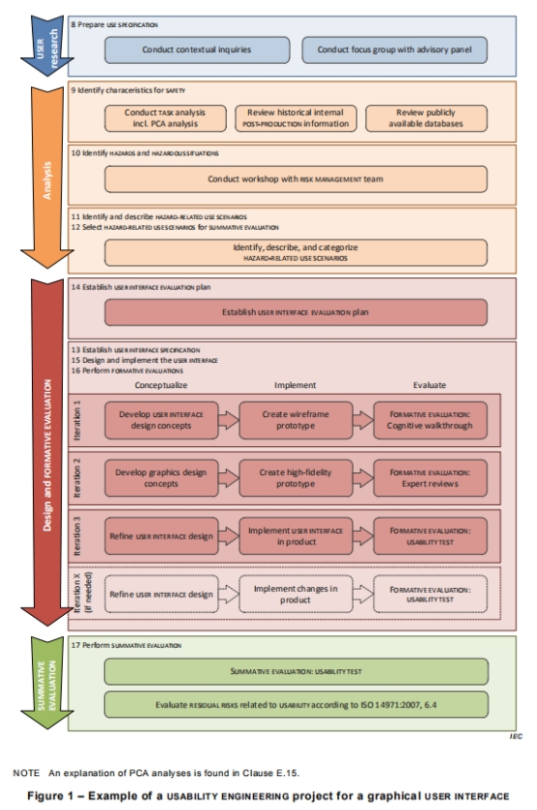

Figure 1 – USABILITY ENGINEERING project for a graphical USER INTERFACE

The project is laid out in four phases:

a) USER research;

b) analysis;

c) design and FORMATIVE EVALUATION;

d) SUMMATIVE EVALUATION.

The implementation phase is planned to have three iterations. However, additional iterations might be necessary in case the FORMATIVE EVALUATION results from previous iterations are not satisfactory.

## Prepare USE SPECIFICATION

The MANUFACTURER shall prepare a USE SPECIFICATION.

The USE SPECIFICATION shall include:

– intended medical indication;

NOTE 1 This can include conditions(s) or disease(s) to be screened, monitored, treated, diagnosed, or prevented.

– intended PATIENT population;

NOTE 2 This can include age group, weight range, health, or condition.

– intended part of the body or type of tissue applied to or interacted with;

– intended USER PROFILE;

– USE ENVIRONMENT;

– operating principle.

NOTE 3 The summary of the MEDICAL DEVICE USE SPECIFICATION is referred to by some authorities having jurisdiction as the ‘statement of intended use’.

Compliance is checked by inspection of the USABILITY ENGINEERING FILE.

## Identify USER INTERFACE characteristics related to SAFETY and potential USE ERRORS

The MANUFACTURER shall identify USER INTERFACE characteristics that could be related to SAFETY as part of a RISK ANALYSIS performed according to EN ISO 14971. This identification may also be performed using the tools and techniques from the USABILITY ENGINEERING PROCESS. This identification shall include consideration of the PRIMARY OPERATING FUNCTIONS that are provided in applicable particular MEDICAL DEVICE SAFETY standards.

Based on the identified USER INTERFACE characteristics and USE SPECIFICATION, the MANUFACTURER shall identify the USE ERRORS that could occur and are related to the USER INTERFACE. This identification may be accomplished by conducting a TASK analysis.

The results of this identification of characteristics related to SAFETY shall be stored in the USABILITY ENGINEERING FILE.

## Identify known or foreseeable HAZARDS and HAZARDOUS SITUATIONS

The MANUFACTURER shall identify known or foreseeable HAZARDS and HAZARDOUS SITUATIONS, which could affect PATIENTS, USERS or others, related to use of the MEDICAL DEVICE. This identification shall be conducted as part of a RISK ANALYSIS performed according to EN ISO 14971.

During the identification of HAZARDS and HAZARDOUS SITUATIONS, the following shall be considered:

– USE SPECIFICATION, including USER PROFILE(S) ;

– information on HAZARDS and HAZARDOUS SITUATIONS known for existing USER INTERFACES of MEDICAL DEVICES of a similar type, if available; and

– identified USE ERRORS.

The results of this identification of HAZARDS and HAZARDOUS SITUATIONS shall be stored in the USABILITY ENGINEERING FILE.

## Identify and describe HAZARD-RELATED USE SCENARIOS

The MANUFACTURER shall identify and describe the reasonably foreseeable HAZARD-RELATED USE SCENARIOS associated with the identified HAZARDS and HAZARDOUS SITUATIONS. The description of each identified HAZARD-RELATED USE SCENARIO shall include all TASKS and their sequences as well as the SEVERITY of the associated HARM.

## Select the HAZARD-RELATED USE SCENARIOS for SUMMATIVE EVALUATION

The MANUFACTURER shall select the HAZARD-RELATED USE SCENARIOS to be included in the SUMMATIVE EVALUATION.

The MANUFACTURER shall select either:

– all HAZARD-RELATED USE SCENARIOS; or

– the subset of the HAZARD-RELATED USE SCENARIOS based on the SEVERITY of the potential HARM that could be caused by USE ERROR (e.g. for which medical intervention would be needed).

The choice of the scheme used to select the HAZARD-RELATED USE SCENARIOS may additionally depend on other circumstances specific to the MEDICAL DEVICE and the MANUFACTURER.

A summary of any selection scheme, the rationale for its use and the results of applying it shall be stored in the USABILITY ENGINEERING FILE.

## Establish USER INTERFACE SPECIFICATION

The MANUFACTURER shall establish and maintain a USER INTERFACE SPECIFICATION.

The USER INTERFACE SPECIFICATION shall consider:

– the USE SPECIFICATION;

– the known or foreseeable USE ERRORS associated with the MEDICAL DEVICE ; and

– the HAZARD-RELATED USE SCENARIOS .

The USER INTERFACE SPECIFICATION shall include:

– testable technical requirements relevant to the USER INTERFACE, including the requirements for those parts of the USER INTERFACE associated with the selected RISK CONTROL measures;

NOTE Technical requirements for the USER INTERFACE can include display colour, character size, or placement of the controls.

– an indication as to whether ACCOMPANYING DOCUMENTATION is required; and

– an indication as to whether MEDICAL DEVICE-specific training is required.

The USER INTERFACE SPECIFICATION shall be stored in the USABILITY ENGINEERING FILE. The USER INTERFACE SPECIFICATION may be integrated into other specifications.

## Establish USER INTERFACE EVALUATION plan

### 7.7.1 General

The MANUFACTURER shall establish and maintain a USER INTERFACE EVALUATION plan for the USER INTERFACE SPECIFICATION.

The USER INTERFACE EVALUATION plan shall

a) document the objective and identify the method of any planned FORMATIVE EVALUATIONS and SUMMATIVE EVALUATIONS;

b) if USABILITY TESTS are employed,

– document the involvement of the representative intended USERS and USER PROFILE to which they belong.

– document the test environment and other conditions of use, based on the USE SPECIFICATION;

– specify whether ACCOMPANYING DOCUMENTATION is provided during the test;

– specify whether MEDICAL DEVICE-specific training is provided prior to the test and the minimum elapsed time between the training and the beginning of the test.

USER INTERFACE EVALUATION methods may be quantitative or qualitative. USER INTERFACE EVALUATION may be performed in a variety of locations, such as, in a laboratory setting, in a simulated USE ENVIRONMENT or in the actual USE ENVIRONMENT.

The USER INTERFACE EVALUATION plan shall be stored in the USABILITY ENGINEERING FILE.

### 7.7.2 FORMATIVE EVALUATION planning

The USER INTERFACE evaluation plan for FORMATIVE EVALUATION shall address:

a) the evaluation methods being used;

b) which part of the USER INTERFACE is being evaluated; and

c) when in the USABILITY ENGINEERING PROCESS to perform each of the USER INTERFACE EVALUATIONS.

### 7.7.3 SUMMATIVE EVALUATION planning

For each selected HAZARD-RELATED USE SCENARIO, the USER INTERFACE EVALUATION plan for SUMMATIVE EVALUATION shall specify:

1. the evaluation method being used and a rationale that the method produces OBJECTIVE EVIDENCE;

b) which part of the USER INTERFACE is being evaluated;

c) where applicable, the criteria for determining whether the information for SAFETY is perceivable, understandable and supports CORRECT USE of the MEDICAL DEVICE;

d) the availability of the ACCOMPANYING DOCUMENTATION and provision of training during the SUMMATIVE EVALUATION; and

e) for a USABILITY TEST,

– the test environment and conditions of use and a rationale for how they are adequately representative of the actual conditions of use; and

– the method of collecting data during the USABILITY TEST for the subsequent analysis of observed USE ERRORS.

The SUMMATIVE EVALUATION may be performed in a single evaluation or multiple evaluations.

## Perform USER INTERFACE design, implementation and FORMATIVE EVALUATION

The MANUFACTURER shall design and implement the USER INTERFACE, including the ACCOMPANYING DOCUMENTATION if needed, and training capability, if needed, as described in the USER INTERFACE SPECIFICATION.

The MANUFACTURER shall utilize, as appropriate, USABILITY ENGINEERING methods and techniques, including FORMATIVE EVALUATION to accomplish this design and implementation.

The results of the utilized FORMATIVE EVALUATION shall be stored in the USABILITY ENGINEERING FILE. Where new USE ERRORS, HAZARDS, HAZARDOUS SITUATIONS or HAZARD-RELATED USE SCENARIOS are discovered during this step, the MANUFACTURER shall repeat the steps of USABILITY ENGINEERING PROCESS.

## Perform SUMMATIVE EVALUATION of the USABILITY of the USER INTERFACE

Upon completion of the design and implementation of the USER INTERFACE, the MANUFACTURER shall perform a SUMMATIVE EVALUATION of each HAZARD-RELATED USE SCENARIO selected on the final or production equivalent USER INTERFACE according to the USER INTERFACE EVALUATION plan. For SUMMATIVE EVALUATION, the MANUFACTURER may use data obtained from the SUMMATIVE EVALUATIONS of products with an equivalent USER INTERFACE together with a technical rationale for how this data is applicable. The results shall be stored in the USABILITY ENGINEERING FILE.

The data from the SUMMATIVE EVALUATION shall be analysed to identify the potential consequences of all USE ERRORS that occurred. If the consequences can be linked to a HAZARDOUS SITUATION, the root cause of each USE ERROR shall be determined. The root causes should be determined based on observations of USER performance and subjective comments from the USER related to that performance.

If new USE ERRORS, HAZARDS, HAZARDOUS SITUATIONS or HAZARD-RELATED USE SCENARIOS are discovered during this data analysis:

– if yes, then the MANUFACTURER shall repeat the activities of USABILITY ENGINEERING PROCESS;

– if not, the MANUFACTURER shall determine whether further improvement of the USER INTERFACE design as it relates to SAFETY is necessary and practicable.

1) if yes, then the MANUFACTURER shall re-enter the USABILITY ENGINEERING PROCESS ;

2) if not, then the MANUFACTURER shall:

## USER INTERFACE OF UNKNOWN PROVENANCE

Instead of all the requirements of 7.1 through 7.9, UOUP may be evaluated according to Annex C of IEC 62366.