**Appendix 2.1 Labels**

* **Labels placed on the device:**

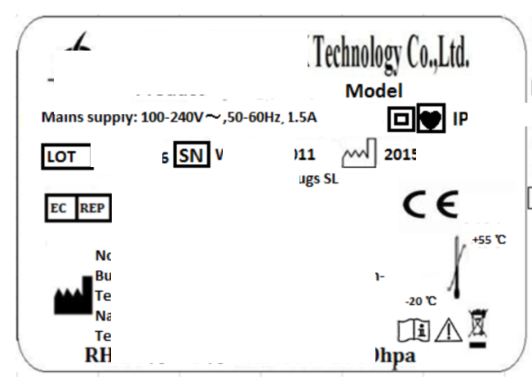

* **Labels on the sterile packaging:**

Not applicable. The device is a non-sterile device.

* **Labels on the sales packaging**

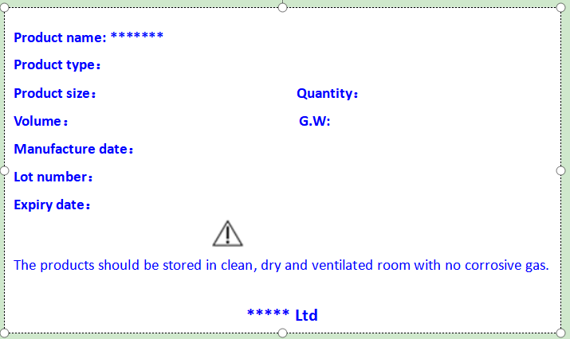

* **Labels on single-unit packaging (only for multi-unit packages):**

*(Not applicable. The device is not packed with multi-unit packages.)*

*【对申报产品的标签的要求请参考MDR 法规第附录I第III章中对标签，产品标准(如IEC 60601-1等)以及EN ISO 15223-1:2016标准中对标签的要求】*