Usability Engineering Process Program

Product Name: {产品名称}
【本处填写产品名称，需要确保全篇技术文档及报告等的名称一致】
Model: {产品型号1}、{产品型号2}、{产品型号N}
【需要罗列本次认证的所有产品型号清单，如型号很多，可以采用另外附件文档的方式给出】
Document No.: {文件编号}
【本处填写本文件的编号】
Edition: {文件版本}
【本处填写本文件的版本】

Drafted by : {XX名字} Date： {年-月-日}

Checked by: {XX名字} Date： {年-月-日}

Approved by: {XX名字} Date： {年-月-日}
【以上分别由负责本文档的编写、审核、批准的人员进行签字和日期，需要注意文件的签署人员和日期等信息与相关体系文档的符合性及逻辑性】

{XXXX公司}

Revision records:
Edition | Effective Date | Summary of revision | Drafted by | Checked by | Approved by
{文件版本1} | {年-月-日} | First release | {XX名字} | {XX名字} | {XX名字}
{文件版本2} | {年-月-日} | {本版本相对上一版本版本更新了****，主要原因是****, 涉及到修改的小节是*****}  【填写本技术文档的版本相对于上一版本更新了哪些内容？为什么更新？以及更新内容具体的地方及小节编号？】 | {XX名字} | {XX名字} | {XX名字}
{文件版本N} | {年-月-日} | {本版本相对上一版本版本更新了****，主要原因是****, 涉及到修改的小节是*****}  【填写本技术文档的版本相对于上一版本更新了哪些内容？为什么更新？以及更新内容具体的地方及小节编号？】 | {XX名字} | {XX名字} | {XX名字}

Table of Contents
1. Scope 3
2. Organization 4
3. RISK CONTROL as it relates to USER INTERFACE design 5
4. Information for safety as it relates to USABILITY 6
5. Usability engineering file 8
6. Tailoring of the USABILITY ENGINEERING effort 8
7. Overview of the usability engineering process 8
7.1 Prepare USE SPECIFICATION 10
7.2 Identify USER INTERFACE characteristics related to SAFETY and potential USE ERRORS 10
7.3 Identify known or foreseeable HAZARDS and HAZARDOUS SITUATIONS 11
7.4 Identify and describe HAZARD-RELATED USE SCENARIOS 12
7.5 Select the HAZARD-RELATED USE SCENARIOS for SUMMATIVE EVALUATION 12
7.6 Establish USER INTERFACE SPECIFICATION 12
7.7 Establish USER INTERFACE EVALUATION plan 13

- Scope
This usability engineering process procedure is intended to provide safety for the patient, user and others related to usability. This usability engineering process procedure intended to address user interactions with the device, {产品名称**} , according to the accompanying documentation , including, but not limited to:
‐ transport
‐ storage
‐ installation
‐ operation
‐ maintenance and repair；and
‐ disposal
USABILITY ENGINEERING activities for a MEDICAL DEVICE shall be planned, carried out, and documented by personnel competent on the basis of appropriate education, training, skills or experience.
Where a documented product realization PROCESS exists, such as that described in Clause 7 of ISO 13485, it shall incorporate the appropriate parts of or reference the USABILITY ENGINEERING PROCESS.
NOTE 1 Subclause 6.2 of ISO 13485 contains additional information relating to personnel competence.
A depiction of the interrelationship between the RISK MANAGEMENT PROCESS of ISO 14971:2007 and the USABILITY ENGINEERING PROCESS described in this IEC 62366-2015 is shown in Figure A.4.
The activities described in Clause 5, as shown Figure A.4, are described in a logical order, but they may be carried out in a flexible order as appropriate.

This procedure shall be conducted through medical device design and development life-cycle once new issue related to use safety is raised.

- Organization

It is recommended for a MEDICAL DEVICE development team to have available adequate USABILITY ENGINEERING expertise and include at least one USABILITY SPECIALIST, as needed.
The USABILITY SPECIALIST should have relevant, appropriate training (e.g. in USABILITY ENGINEERING) and have appropriate MEDICAL DEVICE domain knowledge. USABILITY ENGINEERING expertise can also be gained through formal USABILITY ENGINEERING education, complemented by applicable experience applying the USABILITY ENGINEERING PROCESS to MEDICAL DEVICE development.
USABILITY ENGINEERING expertise can also be provided by individuals who are self-educated in the field and those who have attended courses intended to teach them important USABILITY ENGINEERING concepts and best practices related to MEDICAL DEVICE development.
Among others, the following types of professionals can also participate actively in USABILITY ENGINEERING activities, such as contributing to the USABILITY ENGINEERING project plan, participating in the analysis of USABILITY problems, designing or modifying a MEDICAL DEVICE’S USER INTERFACE or observing and analysing the results of USABILITY TESTS:
a) technical writers responsible for developing the learning tools associated with a MEDICAL DEVICE; tools such as quick reference cards, USERS manuals, other ACCOMPANYING DOCUMENTATION, online help, and educational posters;
b) training course developers and trainers;
c) marketing specialists who have a strong appreciation for USABILITY ENGINEERING and recognize the important differences between USABILITY ENGINEERING and market research;
d) clinicians who have a strong understanding of the USER perspective;
e) developers who build USER INTERFACE prototypes for use in USABILITY TESTS; and
f) engineers and designers who have learned about USABILITY ENGINEERING to enable their own work or manage the USABILITY ENGINEERING efforts of other development team members.

- RISK CONTROL as it relates to USER INTERFACE design
To reduce use-related RISK, the MANUFACTURER shall use one or more of the following options, in the priority listed:
a) inherent SAFETY by design;
b) protective measures in the MEDICAL DEVICE itself or in the manufacturing PROCESS;
c) information for SAFETY.
NOTE Information for SAFETY can also be required by product standards and other sources.
Compliance is checked by inspection of the USABILITY ENGINEERING FILE.

- Information for safety as it relates to USABILITY
When, in accordance with the priorities of 4.1.2 of IEC 62366-2015, information for SAFETY is used as a RISK CONTROL measure, the MANUFACTURER shall subject this information to the USABILITY ENGINEERING PROCESS to determine that the information
– is perceivable by,
– is understandable to, and
– supports CORRECT USE of the MEDICAL DEVICE by USERS of the intended USER PROFILES in the context of the intended USE ENVIRONMENT.
NOTE 1 The relationship between USER perception, cognition and action is shown in Figure A.1 of IEC 62366-2015
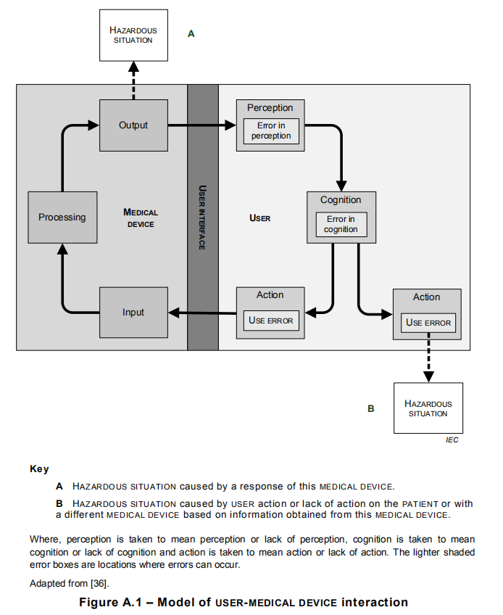
Conscious disregard of such information for SAFETY by the USER is considered to be an intentional act or intentional omission of an act that is counter to or violates NORMAL USE and is also beyond any further reasonable means of USER INTERFACE-related RISK CONTROL by the MANUFACTURER (i.e. ABNORMAL USE).
Compliance is checked by inspection of the information for SAFETY and the USABILITY ENGINEERING FILE.

- Usability engineering file
The results of the usability engineering process shall be recorded in the usability engineering file. The records and other documents that form the usability engineering
file may form part of other documents and files.
Compliance is checked by inspection of the USABILITY ENGINEERING FILE.

- Tailoring of the USABILITY ENGINEERING effort
The level of effort and the choice of methods and tools used to perform the USABILITY ENGINEERING PROCESS may vary based on:
a) the size and COMPLEXITY of the USER INTERFACE;
b) the SEVERITY of the HARM associated with the use of the MEDICAL DEVICE;
c) the extent or complexity of the USE SPECIFICATION;
d) the presence of USER INTERFACE OF UNKNOWN PROVENANCE; and
e) the extent of the modification to an existing MEDICAL DEVICE USER INTERFACE that had been subjected to the USABILITY ENGINEERING PROCESS.
Compliance is checked by inspection of the USABILITY ENGINEERING FILE.

- Overview of the usability engineering process
USABILITY ENGINEERING PROCESS activities should be aligned with other development activities.
Similar to other kinds of projects, such as those developed to ensure manufacturing quality or MEDICAL DEVICE reliability, USABILITY ENGINEERING PROCESS activities are normally described in a detailed plan. The plan can either be a separate plan or be integrated into the overall development plan.
Figure 1 illustrates SABILITY ENGINEERING project. This describes a plan for the development of a graphical USER INTERFACE. It demonstrates how the different methods described can be used to support the USER INTERFACE development.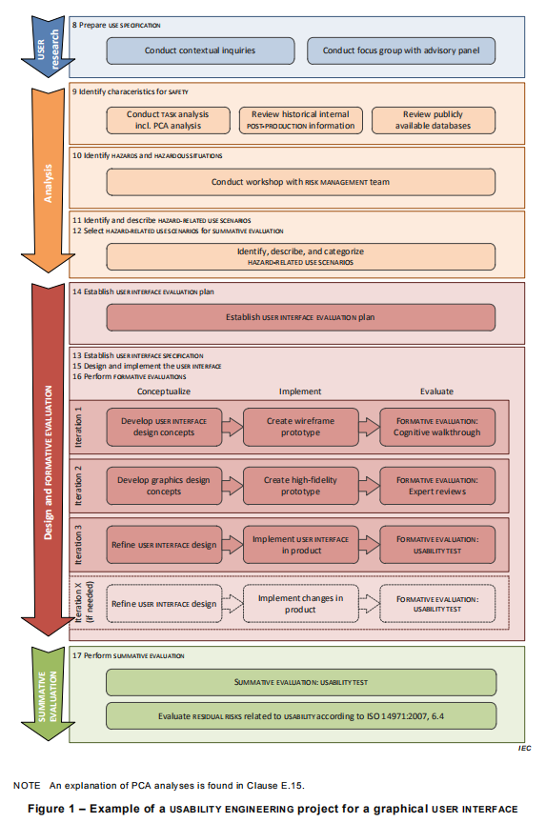

Figure 1 – a USABILITY ENGINEERING project for a graphical USER INTERFACE

The project is laid out in four phases:
a) USER research;
b) analysis;
c) design and FORMATIVE EVALUATION; and
d) SUMMATIVE EVALUATION.
The implementation phase is planned to have three iterations. However, additional iterations might be necessary in case the FORMATIVE EVALUATION results from previous iterations are not satisfactory.

7.1 Prepare USE SPECIFICATION
The MANUFACTURER shall prepare a USE SPECIFICATION.
The USE SPECIFICATION shall include:
– intended medical indication;
NOTE 1 This can include conditions(s) or disease(s) to be screened, monitored, treated, diagnosed, or prevented.
– intended PATIENT population;
NOTE 2 This can include age group, weight range, health, or condition.
– intended part of the body or type of tissue applied to or interacted with;
– intended USER PROFILE;
– USE ENVIRONMENT; and
– operating principle.
NOTE 3 The summary of the MEDICAL DEVICE USE SPECIFICATION is referred to by some authorities having jurisdiction as the ‘statement of intended use’.
Compliance is checked by inspection of the USABILITY ENGINEERING FILE.

7.2 Identify USER INTERFACE characteristics related to SAFETY and potential USE ERRORS
The MANUFACTURER shall identify USER INTERFACE characteristics that could be related to SAFETY as part of a RISK ANALYSIS performed according to EN ISO 14971. This identification may also be performed using the tools and techniques from the USABILITY ENGINEERING PROCESS. This identification shall include consideration of the PRIMARY OPERATING FUNCTIONS that are provided in applicable particular MEDICAL DEVICE SAFETYstandards.
NOTE 1 EN ISO 14971, C.2.29 to C.2.34 provides a list of questions that can be used to identify USER INTERFACE characteristics that could impact SAFETY. The list of questions is not exhaustive.
Based on the identified USER INTERFACE characteristics and USE SPECIFICATION, the MANUFACTURER shall identify the USE ERRORS that could occur and are related to the USER INTERFACE. This identification may be accomplished by conducting a TASK analysis.
NOTE 2 TASK analysis is described in IEC 62366-2.
The results of this identification of characteristics related to SAFETY shall be stored in the USABILITY ENGINEERING FILE.
Compliance is checked by inspection of the USABILITY ENGINEERING FILE.

7.3 Identify known or foreseeable HAZARDS and HAZARDOUS SITUATIONS
The MANUFACTURER shall identify known or foreseeable HAZARDS and HAZARDOUS SITUATIONS, which could affect PATIENTS, USERS or others, related to use of the MEDICAL DEVICE. This identification shall be conducted as part of a RISK ANALYSIS performed according to EN ISO 14971, 4.3 and the first paragraph of EN ISO 14971, 4.4.
During the identification of HAZARDS and HAZARDOUS SITUATIONS, the following shall be considered:
– USE SPECIFICATION, including USER PROFILE(S) ;
– information on HAZARDS and HAZARDOUS SITUATIONS known for existing USER INTERFACES of MEDICAL DEVICES of a similar type, if available; and
– identified USE ERRORS.
The results of this identification of HAZARDS and HAZARDOUS SITUATIONS shall be stored in the USABILITY ENGINEERING FILE.
NOTE 2 During the identification of HAZARDS or HAZARDOUS SITUATIONS, ABNORMAL USE conditions can be identified.
Compliance is checked by inspection of the USABILITY ENGINEERING FILE.

7.4 Identify and describe HAZARD-RELATED USE SCENARIOS
The MANUFACTURER shall identify and describe the reasonably foreseeable HAZARD-RELATED USE SCENARIOS associated with the identified HAZARDS and HAZARDOUS SITUATIONS. The description of each identified HAZARD-RELATED USE SCENARIO shall include all TASKS and their sequences as well as the SEVERITY of the associated HARM.
Compliance is checked by inspection of the USABILITY ENGINEERING FILE.

7.5 Select the HAZARD-RELATED USE SCENARIOS for SUMMATIVE EVALUATION
The MANUFACTURER shall select the HAZARD-RELATED USE SCENARIOS to be included in the SUMMATIVE EVALUATION.
The MANUFACTURER shall select either:
– all HAZARD-RELATED USE SCENARIOS; or
– the subset of the HAZARD-RELATED USE SCENARIOS based on the SEVERITY of the potential HARM that could be caused by USE ERROR (e.g. for which medical intervention would be needed).
The choice of the scheme used to select the HAZARD-RELATED USE SCENARIOS may additionally depend on other circumstances specific to the MEDICAL DEVICE and the MANUFACTURER.
A summary of any selection scheme, the rationale for its use and the results of applying it shall be stored in the USABILITY ENGINEERING FILE.
Compliance is checked by inspection of the USABILITY ENGINEERING FILE.

7.6 Establish USER INTERFACE SPECIFICATION
The MANUFACTURER shall establish and maintain a USER INTERFACE SPECIFICATION.
The USER INTERFACE SPECIFICATION shall consider:
– the USE SPECIFICATION;
– the known or foreseeable USE ERRORS associated with the MEDICAL DEVICE ; and
– the HAZARD-RELATED USE SCENARIOS .
The USER INTERFACE SPECIFICATION shall include:
– testable technical requirements relevant to the USER INTERFACE, including the requirements for those parts of the USER INTERFACE associated with the selected RISK CONTROL measures;
NOTE Technical requirements for the USER INTERFACE can include display colour, character size, or placement of the controls.
– an indication as to whether ACCOMPANYING DOCUMENTATION is required; and
– an indication as to whether MEDICAL DEVICE-specific training is required.
The USER INTERFACE SPECIFICATION shall be stored in the USABILITY ENGINEERING FILE. The USER INTERFACE SPECIFICATION may be integrated into other specifications.
Compliance is checked by inspection of the USABILITY ENGINEERING FILE.

7.7 Establish USER INTERFACE EVALUATION plan
7.7.1 General
The MANUFACTURER shall establish and maintain a USER INTERFACE EVALUATION plan for the USER INTERFACE SPECIFICATION.
The USER INTERFACE EVALUATION plan shall
a) document the objective and identify the method of any planned FORMATIVE EVALUATIONS and SUMMATIVE EVALUATIONS;
NOTE 1 Examples of FORMATIVE EVALUATION and SUMMATIVE EVALUATION methods are given in IEC 62366-2
b) if USABILITY TESTS are employed,
– document the involvement of the representative intended USERS and USER PROFILE to which they belong.
EXAMPLE 1 In a FORMATIVE EVALUATION, clinical personnel from the MANUFACTURER are used for a nurseUSER GROUP.
EXAMPLE 2 In a SUMMATIVE EVALUATION, a panel of practicing intensive care nurses are used for a critical care nursing USER PROFILE.
Multiple USER PROFILES may be combined into a USER GROUP for the purposes of a USABILITY TEST;
– document the test environment and other conditions of use, based on the USE SPECIFICATION;
NOTE 2 These are the specific conditions of use which could affect the USER’S TASKS performance.
EXAMPLE 3 Conditions of use could include location-specific conditions such as lighting, noise and activity levels.
EXAMPLE 4 Conditions of use could include personnel-specific conditions such as use of the MEDICAL DEVICE while wearing personal protective equipment (e.g. surgical gloves and safety goggles).
EXAMPLE 5 Conditions of use could include social conditions such as stress levels and working in teams.
– specify whether ACCOMPANYING DOCUMENTATION is provided during the test;
– specify whether MEDICAL DEVICE-specific training is provided prior to the test and the minimum elapsed time between the training and the beginning of the test.
USER INTERFACE EVALUATION methods may be quantitative or qualitative. USER INTERFACE EVALUATION may be performed in a variety of locations, such as, in a laboratory setting, in a simulated USE ENVIRONMENT or in the actual USE ENVIRONMENT.
NOTE 3 See relevant section for scaling of the USABILITY ENGINEERING effort.
The USER INTERFACE EVALUATION plan may be integrated into other plans.
The USER INTERFACE EVALUATION plan shall be stored in the USABILITY ENGINEERING FILE.
Compliance is checked by inspection of the USABILITY ENGINEERING FILE.
7.7.2 FORMATIVE EVALUATION planning
The USER INTERFACE evaluation plan for FORMATIVE EVALUATION shall address:
a) the evaluation methods being used;
NOTE 1 Objectives for a FORMATIVE EVALUATION can include exploring the extent to which the elements of the USER INTERFACE are recognizable, understandable and operable by the USER.
b) which part of the USER INTERFACE is being evaluated; and
c) when in the USABILITY ENGINEERING PROCESS to perform each of the USER INTERFACE EVALUATIONS.
NOTE 2 The MANUFACTURER can find it helpful to apply focus and effort to the FORMATIVE EVALUATION early on, because the information derived from this is a valuable input to the design PROCESS.
Compliance is checked by inspection of the USABILITY ENGINEERING FILE.
7.7.3 SUMMATIVE EVALUATION planning
For each selected HAZARD-RELATED USE SCENARIO, the USER INTERFACE EVALUATION plan for SUMMATIVE EVALUATION shall specify:
- the evaluation method being used and a rationale that the method produces OBJECTIVE EVIDENCE;
NOTE 1 The SUMMATIVE EVALUATION of the information for SAFETY can require different methods than for other parts of the USER INTERFACE.
b) which part of the USER INTERFACE is being evaluated;
c) where applicable, the criteria for determining whether the information for SAFETY is perceivable, understandable and supports CORRECT USE of the MEDICAL DEVICE;
NOTE 2 The SUMMATIVE EVALUATION of the information for SAFETY is typically completed prior to initiating the SUMMATIVE EVALUATION of the remainder of the USER INTERFACE. It is usually a separate USABILITY TEST with
different USERS.
d) the availability of the ACCOMPANYING DOCUMENTATION and provision of training during the SUMMATIVE EVALUATION; and
NOTE 3 A SUMMATIVE EVALUATION can include training as part of the protocol, as appropriate, to simulate realistic use. An appropriate wait time might be needed between the training and the rest of the SUMMATIVE EVALUATION to allow for representative learning decay.
e) for a USABILITY TEST,
– the test environment and conditions of use and a rationale for how they are adequately representative of the actual conditions of use; and
– the method of collecting data during the USABILITY TEST for the subsequent analysis of observed USE ERRORS.
The SUMMATIVE EVALUATION may be performed in a single evaluation or multiple evaluations.
NOTE 4 The planning for SUMMATIVE EVALUATION will likely not be finalized until after the FORMATIVE EVALUATION has been completed.
NOTE 5 Guidance on the evaluation of the adequacy of RISK CONTROL measures can be found in EN ISO 14971, Clause D.4.
Compliance is checked by inspection of the USABILITY ENGINEERING FILE.
7.8 Perform USER INTERFACE design, implementation and FORMATIVE EVALUATION
The MANUFACTURER shall design and implement the USER INTERFACE, including the ACCOMPANYING DOCUMENTATION if needed, and training capability, if needed, as described in the USER INTERFACE SPECIFICATION.
The MANUFACTURER shall utilize, as appropriate, USABILITY ENGINEERING methods and techniques, including FORMATIVE EVALUATION to accomplish this design and implementation.
The results of the utilized FORMATIVE EVALUATION shall be stored in the USABILITY ENGINEERING FILE. Where new USE ERRORS, HAZARDS, HAZARDOUS SITUATIONS or HAZARD-RELATED USE SCENARIOS are discovered during this step, the MANUFACTURER shall repeat the steps of
USABILITY ENGINEERING PROCESS
NOTE 1 EN ISO 14971, Subclause 6.6 requires that design changes resulting from the USABILITY ENGINEERING PROCESS be reviewed to determine if other HAZARDS or HAZARDOUS SITUATIONS have been generated.
If training on the specific MEDICAL DEVICE is required for the safe use of the MEDICAL DEVICE by the intended USER, the MANUFACTURER shall design and implement a training capability for the EXPECTED SERVICE LIFE of the MEDICAL DEVICE by doing at least one of the following:
– provide the materials necessary for training;
– ensure that the materials necessary for training are available;
– make the training available; or
– make training available to the RESPONSIBLE ORGANIZATION that enables it to train its USERS.
NOTE 2 The training capability is intended to enable the RESPONSIBLE ORGANIZATION to provide training to their USERS for the EXPECTED SERVICE LIFE of the MEDICAL DEVICE.
7.9 Perform SUMMATIVE EVALUATION of the USABILITY of the USER INTERFACE
Upon completion of the design and implementation of the USER INTERFACE, the MANUFACTURER shall perform a SUMMATIVE EVALUATION of each HAZARD-RELATED USE SCENARIO selected on the final or production equivalent USER INTERFACE according to the USER INTERFACE EVALUATION plan. For SUMMATIVE EVALUATION, the MANUFACTURER may use data obtained from the SUMMATIVE EVALUATIONS of products with an equivalent USER INTERFACE together with a technical rationale for how this data is applicable. The results shall be stored in the USABILITY ENGINEERING FILE.
The data from the SUMMATIVE EVALUATION shall be analysed to identify the potential consequences of all USE ERRORS that occurred. If the consequences can be linked to a HAZARDOUS SITUATION, the root cause of each USE ERROR shall be determined. The root causes should be determined based on observations of USER performance and subjective comments from the USER related to that performance.
If new USE ERRORS, HAZARDS, HAZARDOUS SITUATIONS or HAZARD-RELATED USE SCENARIOS are discovered during this data analysis:
– if yes, then the MANUFACTURER shall repeat the activities of USABILITY ENGINEERING PROCESS;
– if not, the MANUFACTURER shall determine whether further improvement of the USER INTERFACE design as it relates to SAFETY is necessary and practicable.
1) if yes, then the MANUFACTURER shall re-enter the USABILITY ENGINEERING PROCESS ;
2) if not, then the MANUFACTURER shall:
NOTE 1 There can be RISK CONTROLS that are not USER INTERFACE-related that are practicable solutions to reduce USER INTERFACE-related RISK.
i) document why improvement is not practicable;
NOTE 2 Guidance for how to determine that further RISK reduction in the USER INTERFACE is not practicable is found in EN ISO 14971, 6.2.
ii) identify the data from the USABILITY ENGINEERING PROCESS needed to determine the RESIDUAL RISK related to use; and
iii) evaluate the RESIDUAL RISK according to EN ISO 14971, 6.4.
NOTE 3 EN ISO 14971, Subclause 6.6 requires that design changes resulting from the USABILITY ENGINEERING PROCESS be reviewed to determine non-USER INTERFACE related HAZARDS or HAZARDOUS SITUATIONS have been generated.
NOTE 4 EN ISO 14971, Clause 7 requires that all RESIDUAL RISK be considered when evaluating the overall RESIDUAL RISK of the MEDICAL DEVICE, including the RESIDUAL RISK associated with USABILITY of the MEDICAL DEVICE.
If the USABILITY ENGINEERING PROCESS detailed in this International Standard has been complied with, then the USABILITY of a MEDICAL DEVICE as it relates to SAFETY is presumed to be acceptable, unless there is OBJECTIVE EVIDENCE to the contrary.
NOTE 5 Such OBJECTIVE EVIDENCE can subsequently originate from POST-PRODUCTION surveillance.
Compliance is checked by inspection of the USABILITY ENGINEERING FILE and by application of the requirements of EN ISO 14971, 6.4.
7.10 USER INTERFACE OF UNKNOWN PROVENANCE
Instead of all the requirements of 7.1 through 7.9, UOUP may be evaluated according to Annex C of IEC 62366.
Compliance is checked by application of Annex C of IEC 62366.

